Sankalp Ronge
SAP id:590027268
C Lab Report
List of Experiments

Exp 1: Installation,Environment Setup and starting with C language
- Write a C program to print “HelloWorld”

Flowchart:
START

Print "Hello World”
│ World"
F
END

ALGORITHIM:
Step 1: Start the program
Step 2: Display the message "Hello World" on the screen
Step 3: End the program

Pseudo code:
START
PRINT "Hello World"
END

Code:

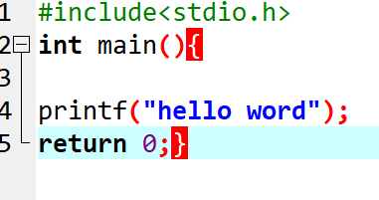
Result:
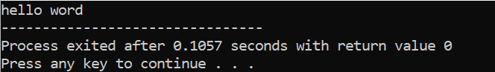

- Write a C Program to print the address in multiple lines(newline).

Flowchart:

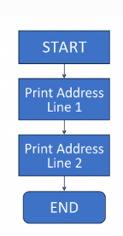
Algorithim:
Step 1: Start the program
Step 2: Print the first line of the address
Step 3: Print the second line of the address
Step 4: Print the third line of the address
Step 5: End the program

Pseudo code:
START
PRINT "Your Address Line 1"
PRINT "Your Address Line 2"
PRINT "Your Address Line 3"
END

Code:
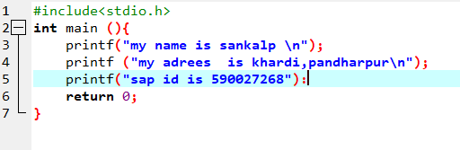

Result
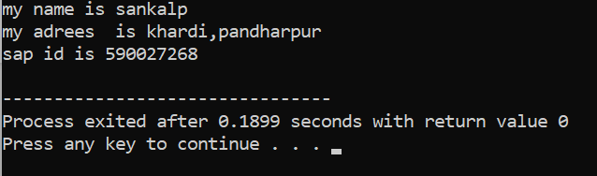

3.write a program that prompts the user to enter their name and age.
Algorithim:
Step 1: Start the program
Step 2: Display a message asking the user to enter their name
Step 3: Accept the user's name
Step 4: Display a message asking the user to enter their age
Step 5: Accept the user's age
Step 6: Display the entered name and age
Step 7: End the program

Pseudo code:
START
ASK user to enter name
READ name
ASK user to enter age
READ age
PRINT name and age
END

Flowchart
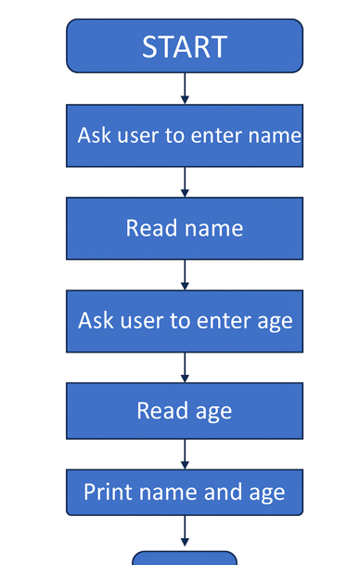
END

Code:
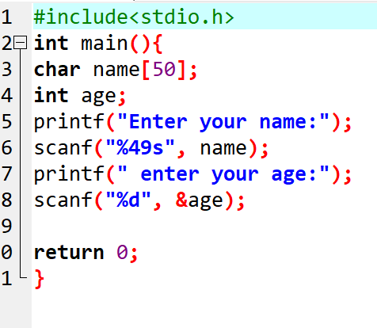
Result
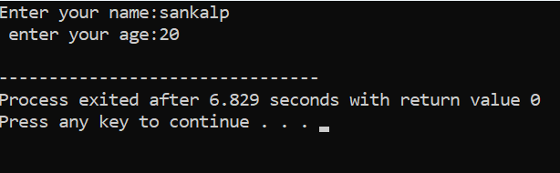

4. Write a C program to add two numbers, take number from user.

Algorithim:
• Start
• Declare variables a, b, and sum.
• Read the first number and store it in a.
• Read the second number and store it in b.
• Calculate sum = a + b.
• Display the value of sum.
• End

Pseudo code:
START
DECLARE a, b, sum

PRINT "Enter first number:"
INPUT a

PRINT "Enter second number:"
INPUT b

sum ← a + b

PRINT "The sum is:", sum
END
Flowchart:
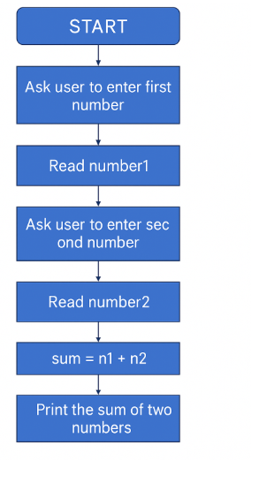
END

Code:
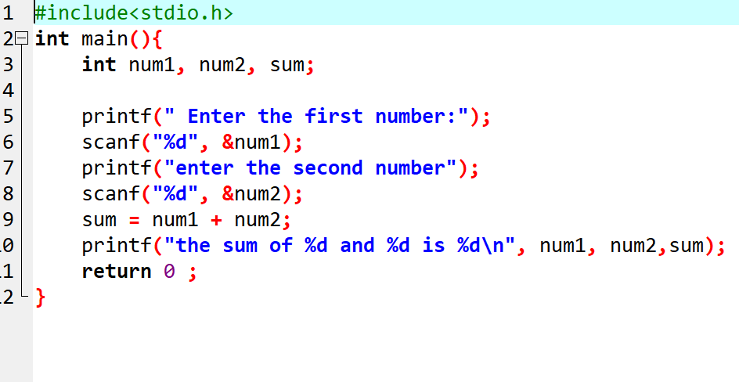

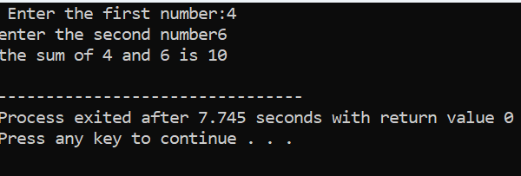

- Opetators:
1. WAP a C program calculate the area and perimeter of rectangle based on its length and width.
Algorithim:
• Start
• Declare variables: length, width, area, perimeter.
• Ask user to enter the length.
• Read the length.
• Ask user to enter the width.
• Read the width.
• Calculate area → area = length × width
• Calculate perimeter → perimeter = 2 × (length + width)
• Display area and perimeter.
• End

Pseudo code:
START

DECLARE length, width, area, perimeter

PRINT "Enter length:"
INPUT length

PRINT "Enter width:"
INPUT width

area ← length * width
perimeter ← 2 * (length + width)

PRINT "Area =", area
PRINT "Perimeter =", perimeter

END

Flowchart:

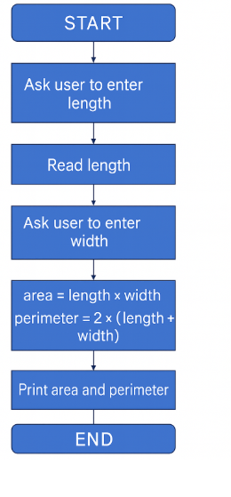

Code:

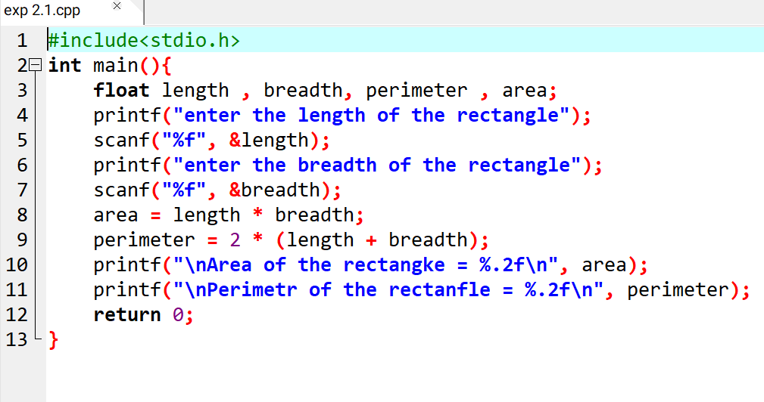
result
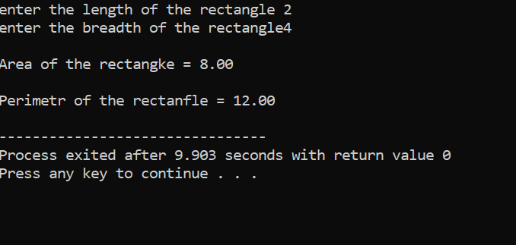

2. 2. WAP a C program to Convert temperature from Celsius to Fahrenheit using the formula :F=(C*9/5)+32
Algorithim
- Start
- Declare variables: C (Celsius), F (Fahrenheit)
- Ask user to enter temperature in Celsius
- Read the value of C
- Calculate Fahrenheit using
F = (C × 9/5) + 32
- Display the value of F
- End
Pseudo code:
START

DECLARE C, F

PRINT "Enter temperature in Celsius:"
INPUT C

F ← (C * 9/5) + 32

PRINT "Temperature in Fahrenheit =", F

END

Flowchart:
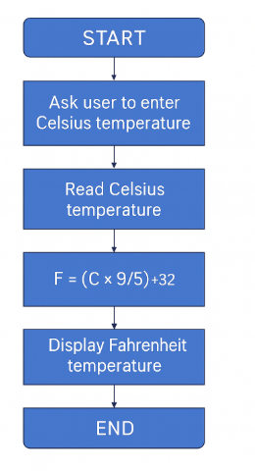
Code:
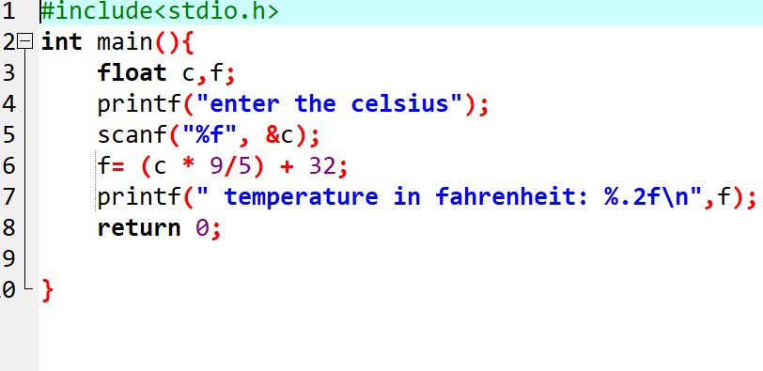
Result:
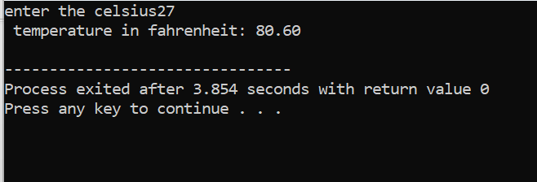

- Conditional statements
- 1. WAP to take check if the triangle is valid or not. If the validity is established, do check if the triangle is isosceles,equilateral, rightangle,orscalene.Take sides of the triangle as input from a user.

Algorithim
• Start
• Input the three sides: a, b, c.
• Check validity of triangle using the rule:
- A triangle is valid if
a + b > c AND a + c > b AND b + c > a
• If the triangle is not valid,
- Print "Triangle is not valid"
- Go to End
• If triangle is valid, check type:
- If a == b == c → It is Equilateral
- Else if a == b OR b == c OR a == c → It is Isosceles
- Else if a² + b² = c² OR a² + c² = b² OR b² + c² = a² → Right-Angle Triangle
- Else → Scalene Triangle
• Print the type of triangle.
• End

Pseudo code:
START

INPUT a, b, c

IF (a + b > c) AND (a + c > b) AND (b + c > a) THEN
PRINT "Triangle is valid"

IF (a == b AND b == c) THEN
PRINT "Equilateral Triangle"
ELSE IF (a == b OR b == c OR a == c) THEN
PRINT "Isosceles Triangle"
ELSE IF (a*a + b*b == c*c OR
a*a + c*c == b*b OR
b*b + c*c == a*a) THEN
PRINT "Right-Angle Triangle"
ELSE
PRINT "Scalene Triangle"
ENDIF

ELSE
PRINT "Triangle is not valid"
ENDIF

END

Flowchart:
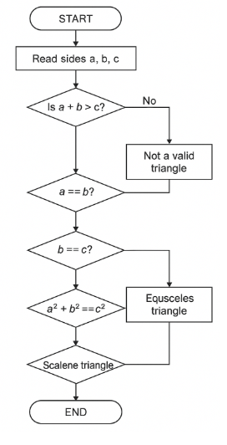
code:
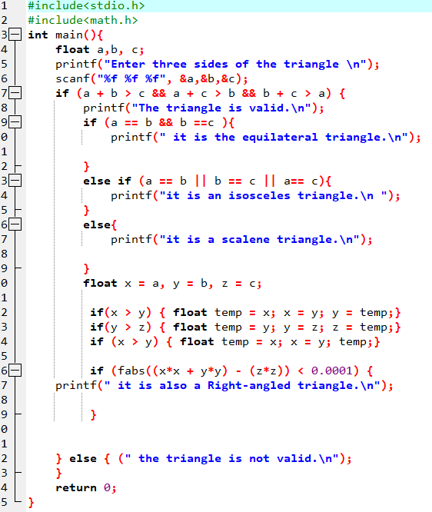
Result:
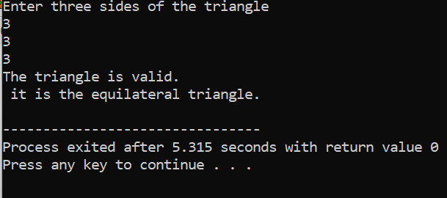

- 2. WAPtocomputetheBMI Indexof thepersonandprint theBMIvaluesasper thefollowingranges.YoucanusethefollowingformulatocomputeBMI= weight(kgs)/Height(Mts)*Height(Mts).

Algorithim
• Start
• Input weight (kg) and height (m)
• Calculate BMI = weight / (height × height)
• Check BMI range:
- BMI < 15 → Starvation
- 15.1 ≤ BMI ≤ 17.5 → Anorexic
- 17.6 ≤ BMI ≤ 18.5 → Underweight
- 18.6 ≤ BMI ≤ 24.9 → Ideal
- 25 ≤ BMI ≤ 29.9 → Overweight
- 30 ≤ BMI ≤ 39.9 → Obese
- BMI ≥ 40 → Morbidly Obese
• Print BMI and category
• End

Pseudo code
START
INPUT weight, height
BMI = weight / (height * height)

IF BMI < 15 THEN
PRINT "Starvation"
ELSE IF BMI >= 15.1 AND BMI <= 17.5 THEN
PRINT "Anorexic"
ELSE IF BMI >= 17.6 AND BMI <= 18.5 THEN
PRINT "Underweight"
ELSE IF BMI >= 18.6 AND BMI <= 24.9 THEN
PRINT "Ideal"
ELSE IF BMI >= 25 AND BMI <= 29.9 THEN
PRINT "Overweight"
ELSE IF BMI >= 30 AND BMI <= 39.9 THEN
PRINT "Obese"
ELSE
PRINT "Morbidity Obese"
END IF
END

Flowchart

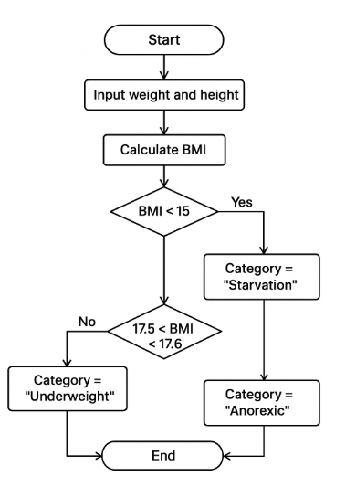

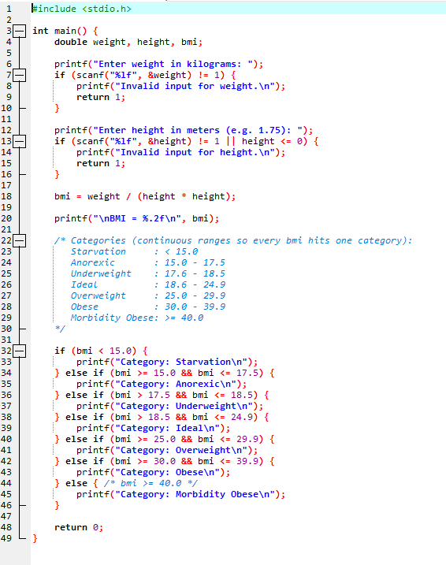

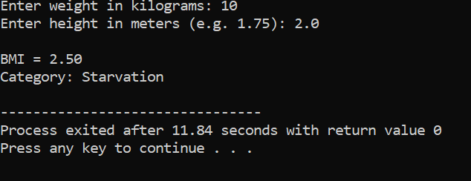

  - WAP to check if three points (x1,y1),(x2,y2) and (x3,y3) are collinear or not
Flowchart
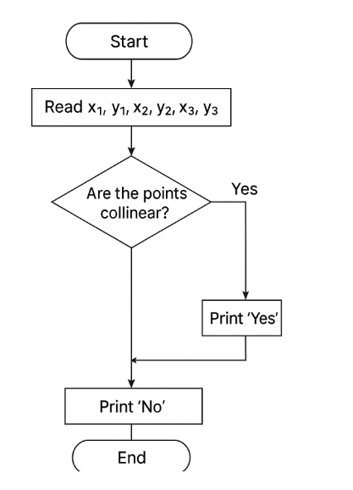
- Start
- Input the coordinates $x1,y1,x2,y2,x3,y3$.
- Calculate the area of the triangle formed by the three points using the formula:
$$\text{Area}=\frac{1}{2}[x1(y2-y3)+x2(y3-y1)+x3(y1-y2)]$$
- If Area = 0, then the points are collinear.
- Otherwise, the points are not collinear.
- End
pseudo code
Start
Input x1, y1
Input x2, y2
Input x3, y3

area = x1*(y2 - y3) + x2*(y3 - y1) + x3*(y1 - y2)

If area == 0 then
Print "Points are collinear"
Else
Print "Points are not collinear"
EndIf
End
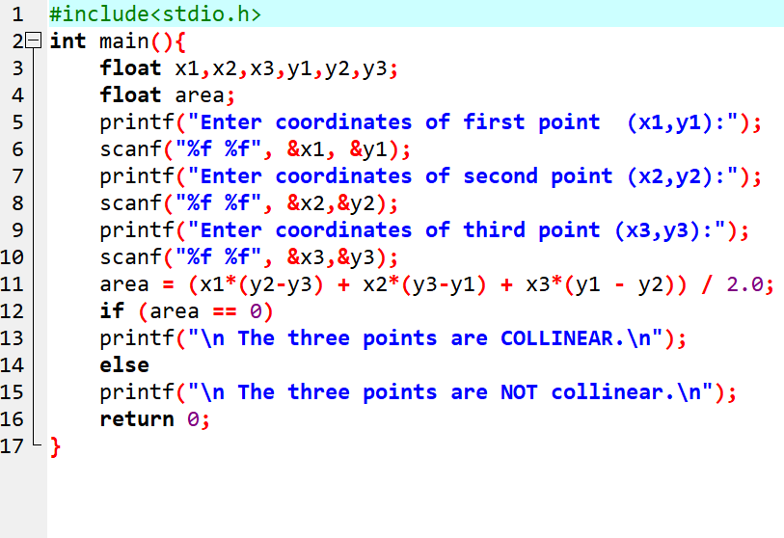

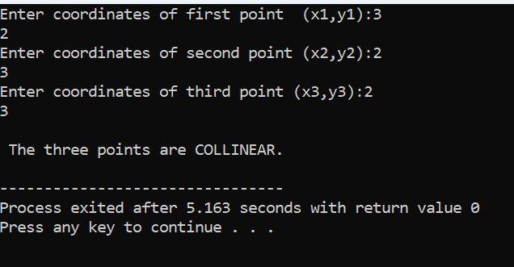

- According to the Gregorian calendar, it was Monday on the date 01/01/01. If Any year is input through the keyboard write a program to find out what is the day on 1st January of this year algorithim and pseudo code
Flowchart
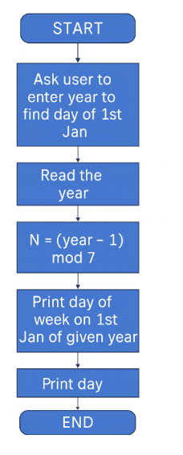
Algorithim
• Start
• Input the year Y
• Initialize total_days = 0
• Loop through all years from 1 to Y-1:
- If the year is a leap year (divisible by 4, not divisible by 100 unless divisible by 400), add 366 to total_days
- Else add 365 to total_days
• Calculate day_index = (total_days + 1) % 7
- (We add 1 because 01/01/0001 is Monday → index 1)
• Map day_index to day of week:
- 0 → Sunday, 1 → Monday, 2 → Tuesday, …, 6 → Saturday
• Print the day of the week for 1st January of year Y
• End

START
INPUT year Y
total_days = 0

FOR i = 1 TO Y-1
IF (i % 4 == 0 AND i % 100 != 0) OR (i % 400 == 0) THEN
total_days = total_days + 366
ELSE
total_days = total_days + 365
END IF
END FOR

day_index = (total_days + 1) % 7 // 01/01/0001 was Monday (index 1)

SWITCH(day_index)
CASE 0: PRINT "Sunday"
CASE 1: PRINT "Monday"
CASE 2: PRINT "Tuesday"
CASE 3: PRINT "Wednesday"
CASE 4: PRINT "Thursday"
CASE 5: PRINT "Friday"
CASE 6: PRINT "Saturday"
END SWITCH
END
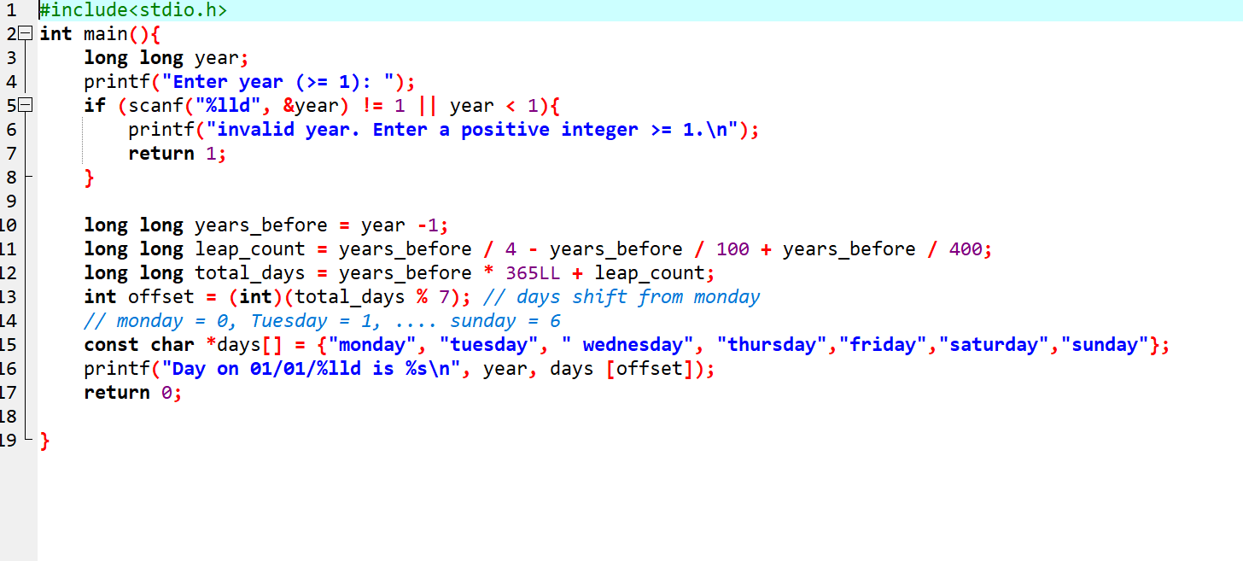
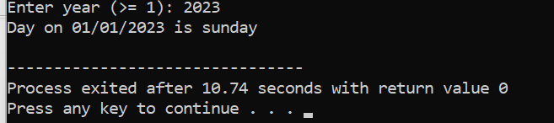

- WAP using ternary operator, the user should input the length and breadth of a rectangle ,one has to find out which rectangle has the highest perimeter.The minimum number of rectangles should be three
Flowchart
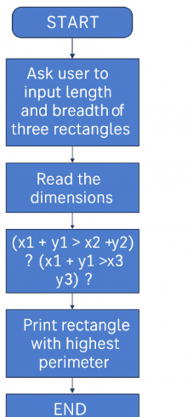

Algorithm
- Start
- Input length and breadth of Rectangle 1 → l1, b1
- Input length and breadth of Rectangle 2 → l2, b2
- Input length and breadth of Rectangle 3 → l3, b3
- Calculate the perimeter of each rectangle:
  - p1 = 2 * (l1 + b1)
  - p2 = 2 * (l2 + b2)
  - p3 = 2 * (l3 + b3)
- Use ternary operator to find the maximum perimeter:
  - max = (p1 > p2) ? ((p1 > p3) ? p1 : p3) : ((p2 > p3) ? p2 : p3)
- Print the rectangle with the highest perimeter and its value
- End

Pseudo code
START
// Input lengths and breadths of three rectangles
INPUT l1, b1
INPUT l2, b2
INPUT l3, b3

// Calculate perimeters
p1 = 2 * (l1 + b1)
p2 = 2 * (l2 + b2)
p3 = 2 * (l3 + b3)

// Find maximum perimeter using ternary operator
max = (p1 > p2) ? ((p1 > p3) ? p1 : p3) : ((p2 > p3) ? p2 : p3)

// Print result
PRINT "Maximum perimeter rectangle = ", max
END

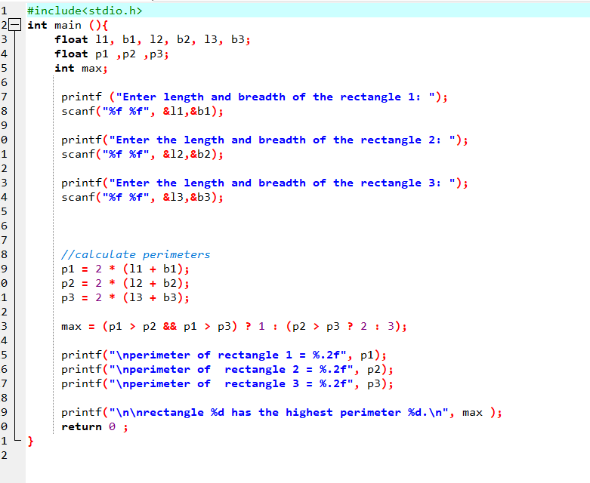
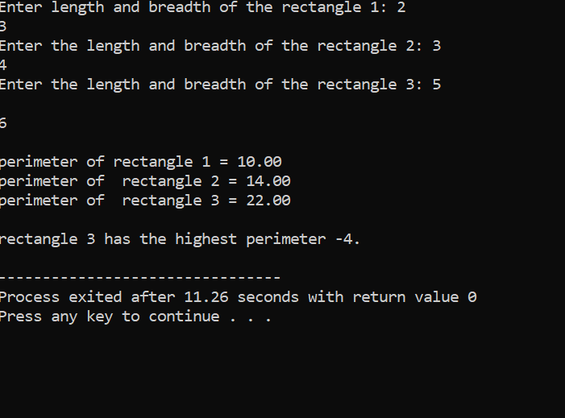

Experiment3.2:Loops
  - WAP to enter number still the user wants. At the end, it should display the count of positive,negative,andZero esentered.
Flowchart
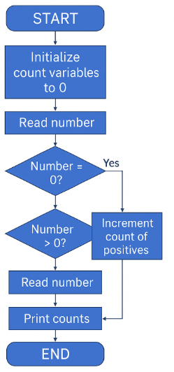
Algorithm
- Start
- Initialize counters: pos = 0, neg = 0, zero = 0
- Repeat the following steps until the user wants to stop:
  - Input a number num
  - If num > 0 → increment pos
  - Else if num < 0 → increment neg
  - Else → increment zero
  - Ask the user if they want to continue (Yes/No)
- After the loop ends, display the counts of positive, negative, and zero numbers
- End
Pseudo code
START
pos = 0
neg = 0
zero = 0

DO
INPUT num
IF num > 0 THEN
pos = pos + 1
ELSE IF num < 0 THEN
neg = neg + 1
ELSE
zero = zero + 1
END IF
ASK user "Do you want to enter another number? (y/n)"
WHILE user input is 'y'

PRINT "Count of Positive numbers: ", pos
PRINT "Count of Negative numbers: ", neg
PRINT "Count of Zeroes: ", zero
END
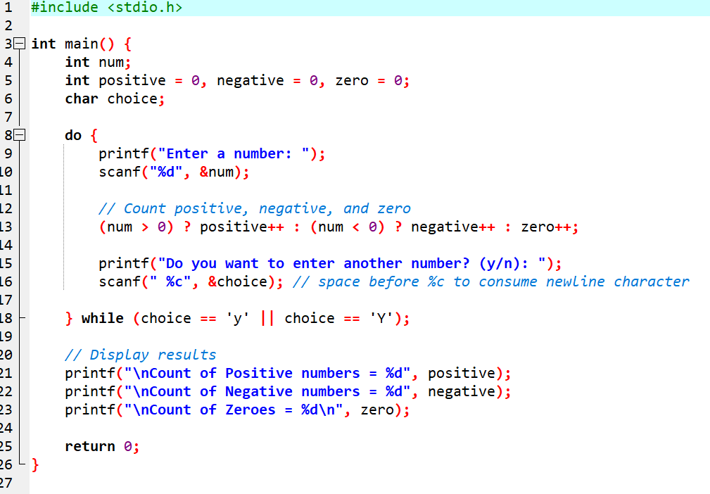
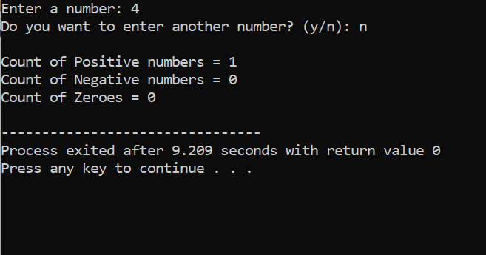

2.Write a program to input a number from the user and print its multiplication table from 1 to 10 in the format:
Flowchart
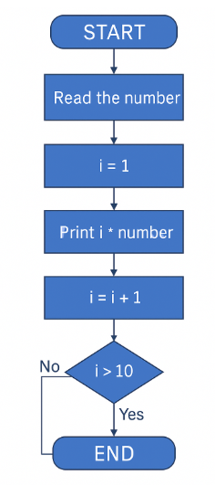
Algorithim
- Start
- Input a number n from the user
- Initialize counter i = 1
- Repeat the following steps while i <= 10:
  - Calculate result = n * i
  - Print n * i = result
  - Increment i by 1
- End
Pseudo code
START
INPUT n
i = 1
WHILE i <= 10
result = n * i
PRINT n, "*", i, "=", result
i = i + 1
END WHILE
END
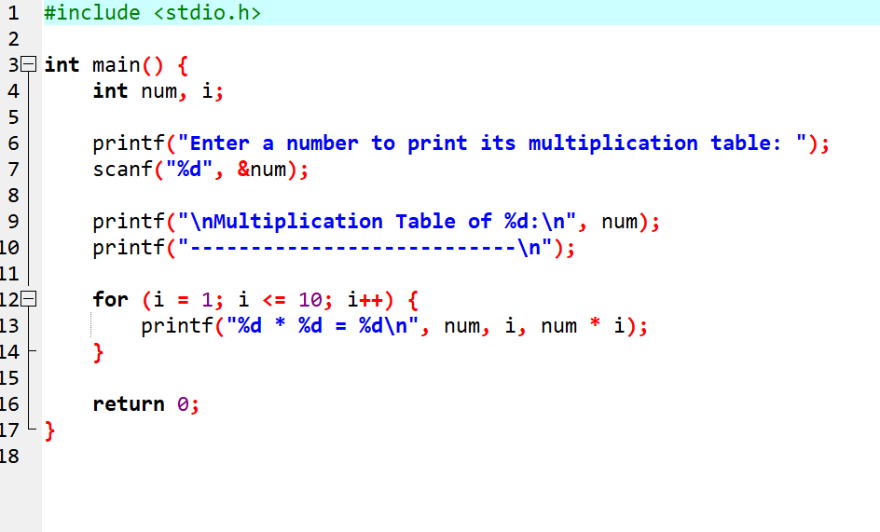

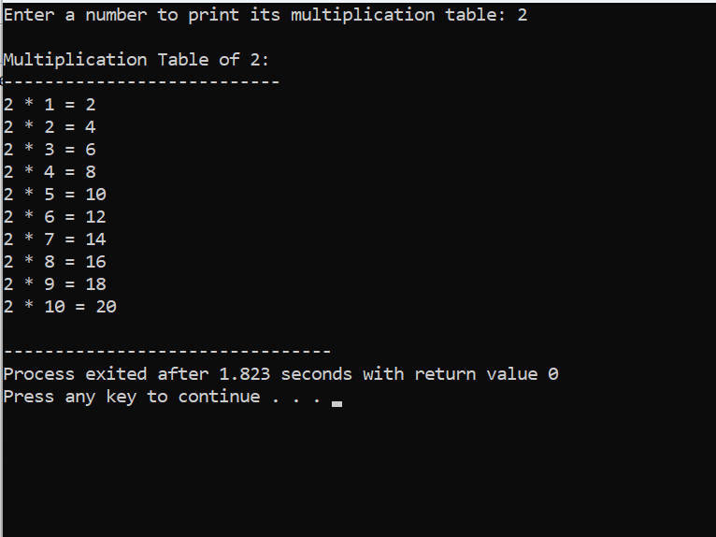
3. 3. WAP to generate the following set of output.
a.
1
23
456
b.
1
11

1 21
1 331
1 4641
A flowchart
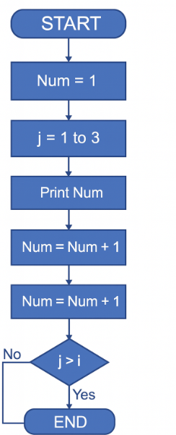
Algorithim
- Start
- Set num = 1
- For each row from 1 to 3:
a. For each column from 1 to row number:
  - Print num
  - Increment num by 1
b. Move to next line
- End
Pseudo code
BEGIN
num ← 1

FOR row ← 1 TO 3 DO
FOR col ← 1 TO row DO
PRINT num
num ← num + 1
END FOR
PRINT newline
END FOR

END
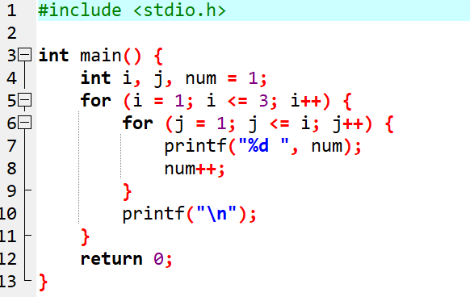
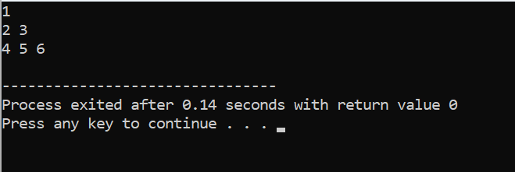
b.Algorithim
- Start
- Input number of rows n
- For each row i from 0 to n−1:
a. Set value = 1
b. Print value
c. For each column j from 1 to i:
  - Compute value using Pascal formula:
  - value = value * (i - j + 1) / j
  - Print value
d. Move to next line
- End
Pseudo code
BEGIN
INPUT n

FOR i ← 0 TO n-1 DO
value ← 1
PRINT value

FOR j ← 1 TO i DO
value ← value * (i - j + 1) / j
PRINT value
END FOR

PRINT newline
END FOR

END
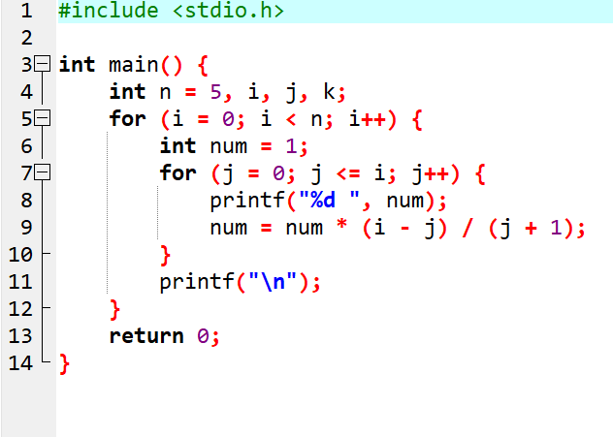
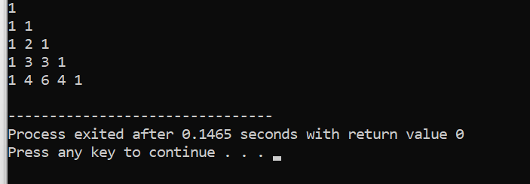

5 5. Ramanujan Number is the smallest number that can be expressed as the sum of two cubes in two different ways. WAP to print all such numbers up to a reasonable limit. Example of Ramanujan number: 1729 12^3 + 1^3 and 10^3 + 9^3. for a number L=20(that is limit)
Flowchart
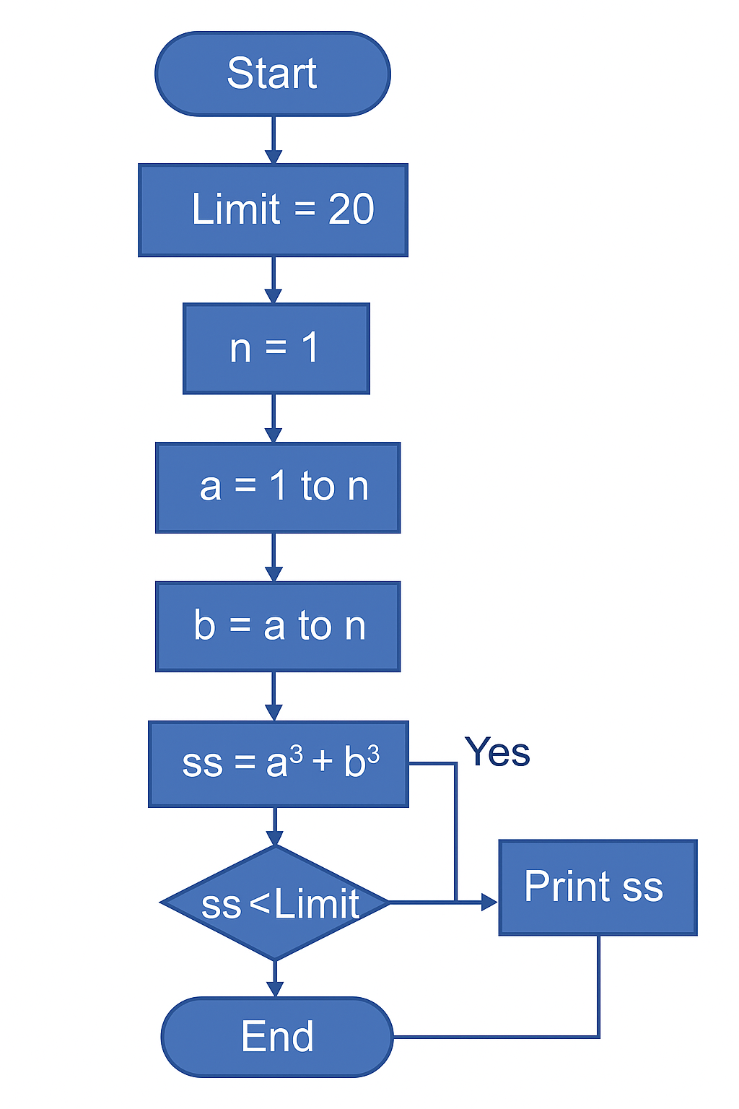
Algorithim
- Start
- Input limit L
- For every pair (a, b) where 1 ≤ a < b ≤ L
  - Compute S1 = a³ + b³
- For every different pair (c, d) where 1 ≤ c < d ≤ L
  - Compute S2 = c³ + d³
  - If S1 = S2 and (a,b) ≠ (c,d) → It is a Ramanujan number
- Print the number and the two cube representations
- End
Pseudo code

BEGIN
INPUT L

FOR a = 1 TO L
FOR b = a+1 TO L
S1 = a^3 + b^3

FOR c = a TO L
FOR d = c+1 TO L
S2 = c^3 + d^3

IF S1 = S2 AND (a != c OR b != d) THEN
PRINT S1, a, b, c, d
ENDIF
ENDFOR
ENDFOR

ENDFOR
ENDFOR
END
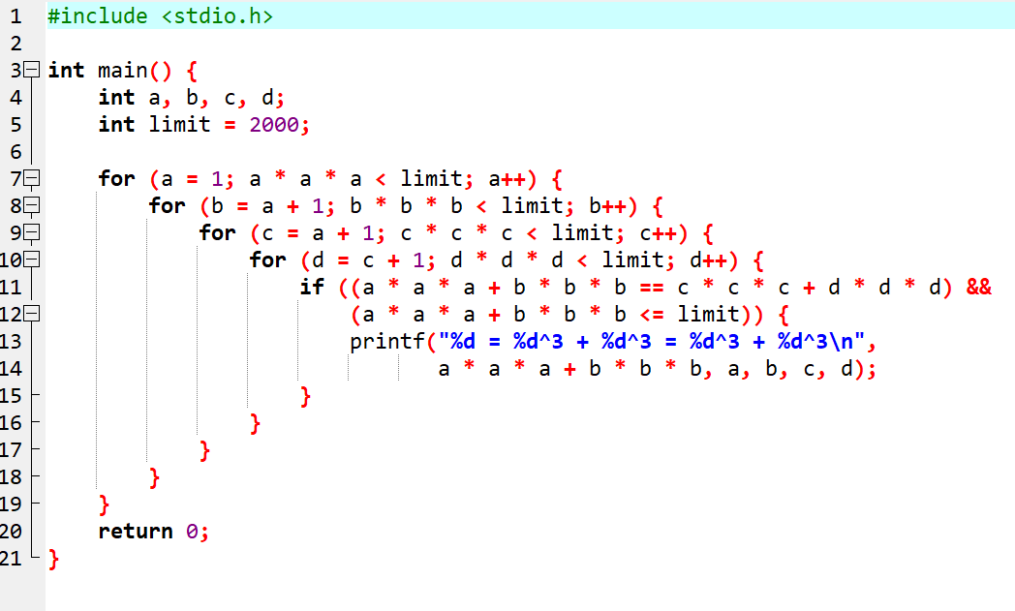
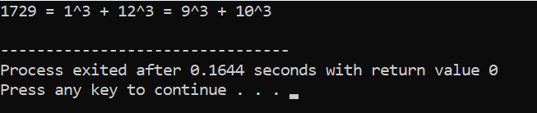
Q4 4. The population of a town is 100000. The population has increased steadily at the rate of 10% per year for the last 10 years. Write a program to determine the population at the end of each year in the last decade
Flowchart
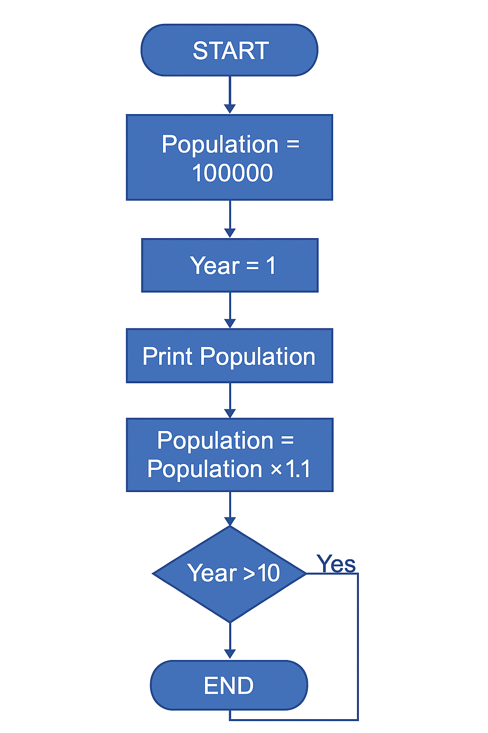
Algorithim
• Start
• Set initial population = 100000
• Set growth rate = 10%
• Repeat for 10 years:
- New population = old population + (10% of old population)
- Print the population for that year
- Update old population = new population
• End
Pseudo code
BEGIN
population ← 100000
rate ← 0.10

FOR year = 1 TO 10
population ← population + (population * rate)
PRINT "Year", year, "Population =", population
END FOR
END
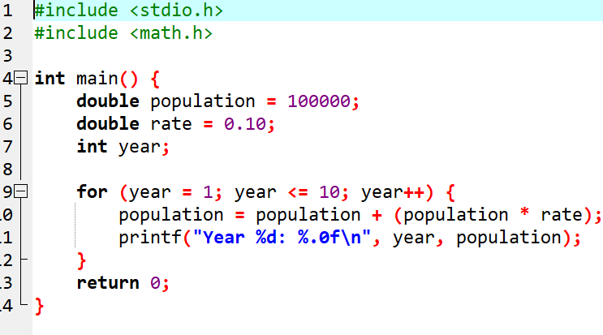
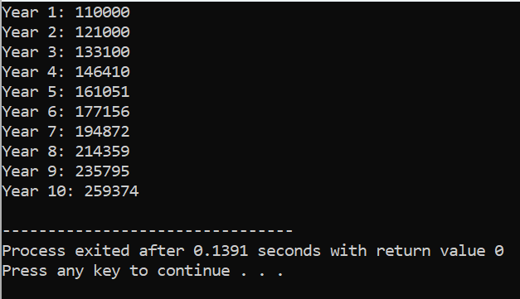
Experiment 4: Variable and Scope of Variable
  - Declare a global variable outside all functions and use it inside various functions to understand its accessibility
Flowchart
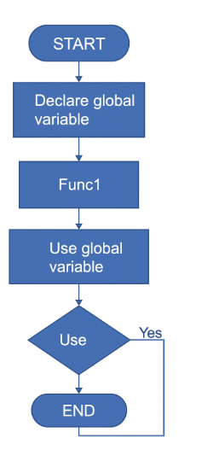

Algorithim

- Start
- Declare a global variable int g outside all functions
- In main() print the value of g
- Call func1() → it prints and modifies g
- Call func2() → it prints the updated value of g
- End

pseudo code
DECLARE g = 10 // global variable

FUNCTION func1()
PRINT g
g = g + 5
END FUNCTION

FUNCTION func2()
PRINT g
END FUNCTION

BEGIN MAIN
PRINT g
CALL func1()
CALL func2()
END MAIN
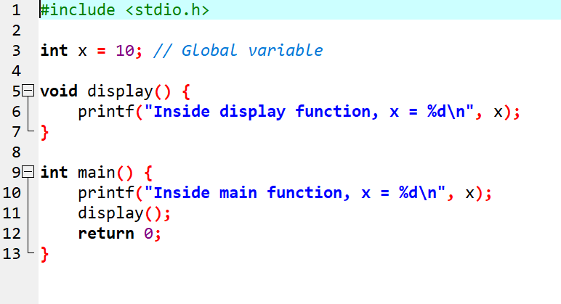

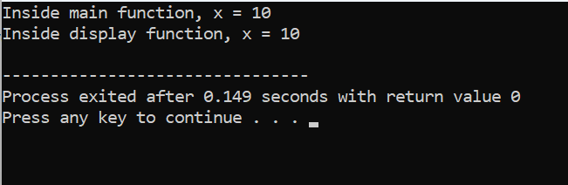
  - . Declare a local variable inside a function and try to access it outside the function. Compare this with accessing the global variable from within the function.
Flowchart
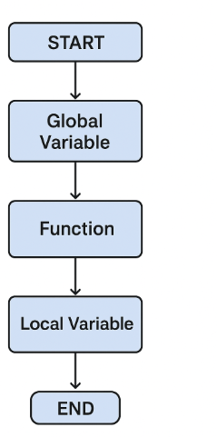
Algorithim
• Start
• Declare a global variable outside all functions
• Define a function func1()
- Inside this function, declare a local variable
- Print the local variable
- Print the global variable
• In the main() function:
- Call func1()
- Try to access the local variable → note that this is not allowed
- Print the global variable (this is allowed)
• End
Pseudo code
DECLARE globalVar = 50 // global variable

FUNCTION func1()
DECLARE localVar = 10 // local variable
PRINT "Inside func1, localVar =", localVar
PRINT "Inside func1, globalVar =", globalVar
END FUNCTION

BEGIN MAIN
CALL func1()

// Attempting to access localVar here is NOT allowed
// PRINT localVar --> This will give an error

PRINT "Inside main, globalVar =", globalVar
END MAIN
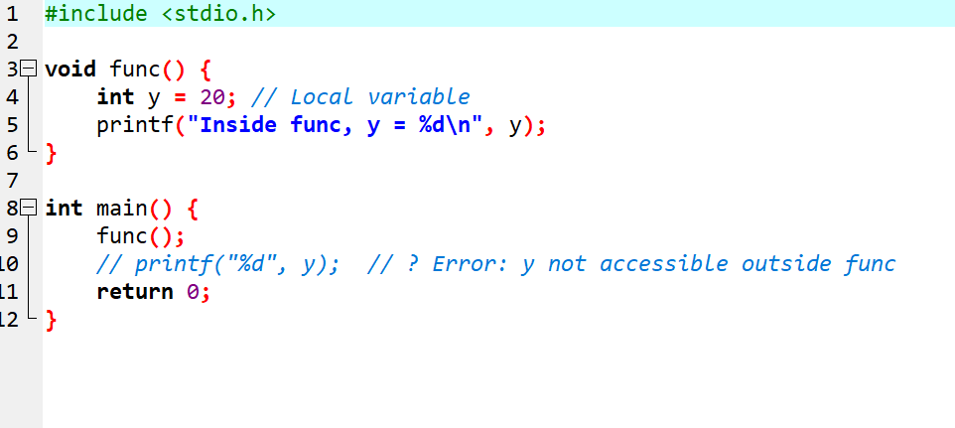
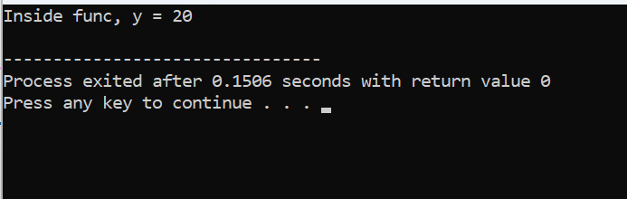
  - . Declare variables within different code blocks (enclosed by curly braces) and test their accessibility within and outside those blocks.
Flowchart
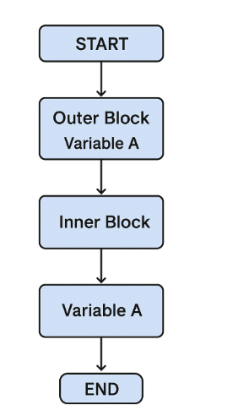

Algorithim
Start
Step 2: Declare a global variable (optional, only to compare with block variables)
Step 3: Begin main function
Step 4: Declare a variable inside the main block
Step 5: Create an inner block using { }
Step 6: Declare variables inside this inner block
Step 7: Try to access outer block variables inside the inner block (allowed)
Step 8: End the inner block
Step 9: Try to access variables declared inside the inner block from outside (not allowed → will cause error)
Step 10: End main function
Step 11: Stop
Pseudo code
START

DECLARE globalVar = 10 // optional

FUNCTION main
{
DECLARE a = 5
PRINT a // accessible

BEGIN BLOCK
{
DECLARE b = 20
PRINT b // accessible
PRINT a // a is accessible inside inner block
}
END BLOCK

PRINT a // accessible
PRINT b // ERROR: b not accessible outside inner block
}

END
STOP

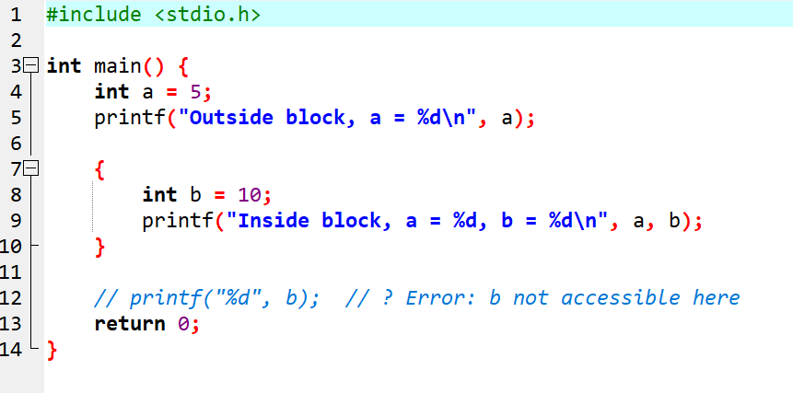

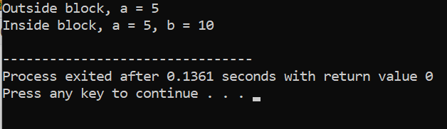
  - Declare a static local variable inside a function. Observe how its value perisists across function calls.
Flowchart
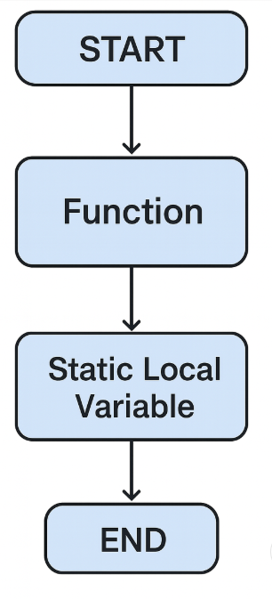
Algorithim
Step 1: Start
Step 2: Define a function that contains a static local variable
Step 3: Initialize the static variable only once
Step 4: Each time the function is called, increase the static variable
Step 5: Print the value of the static variable
Step 6: Call the function multiple times from main()
Step 7: Observe that the static variable keeps its value between calls
Step 8: Stop
Pseudo code
START

FUNCTION demo()
{
DECLARE STATIC count = 0 // initialized only once
count = count + 1
PRINT "Count =", count
}

FUNCTION main()
{
CALL demo() // Output: Count = 1
CALL demo() // Output: Count = 2
CALL demo() // Output: Count = 3
}

STOP
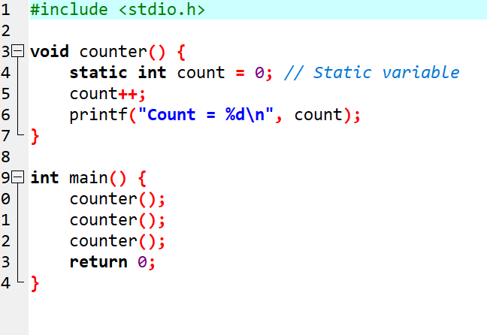
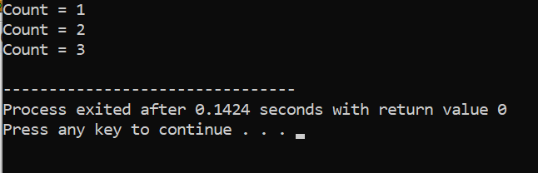
Experiment 5: Array
  - WAP to read a list of integers and store it in a single dimensional array. Write a Cprogram to print the second largest integer in a list of integers.
Flowchart
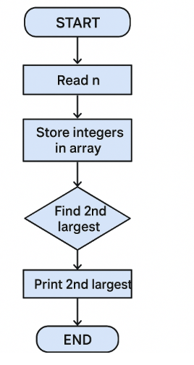
Algorithims
: Start
Step 2: Read the number of elements n
Step 3: Declare an array of size n
Step 4: Read all n integers into the array
Step 5: Initialize two variables:
- largest = -∞
- secondLargest = -∞
Step 6: Traverse the array
• If current number > largest
→ set secondLargest = largest
→ set largest = current number
• Else if current number > secondLargest AND current number ≠ largest
→ update secondLargest = current number
Step 7: Print secondLargest
Step 8: Stop

START

READ n
DECLARE array[n]

FOR i = 0 to n-1
READ array[i]
END FOR

SET largest = -infinity
SET secondLargest = -infinity

FOR i = 0 to n-1
IF array[i] > largest THEN
secondLargest = largest
largest = array[i]
ELSE IF array[i] > secondLargest AND array[i] != largest THEN
secondLargest = array[i]
END IF
END FOR

PRINT "Second Largest =", secondLargest

STOP

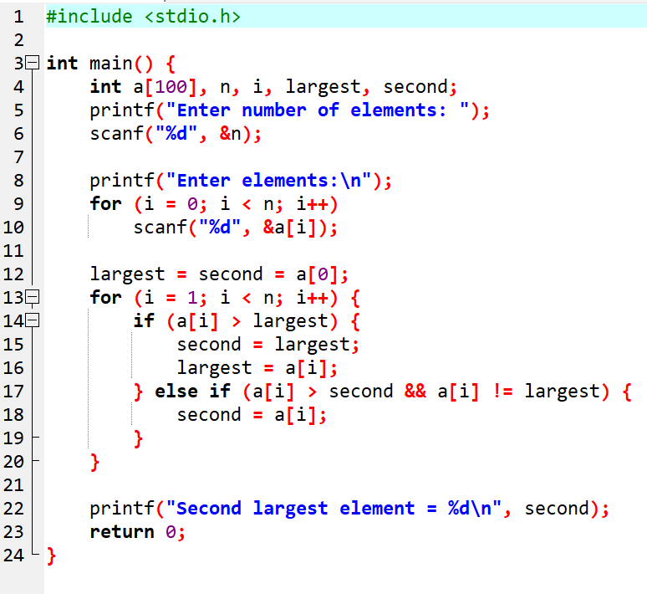
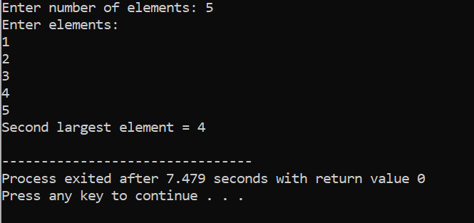
  - WAP to read a list of integers and store it in a single dimensional array. Write a C program to count and display positive, negative, odd, and even numbers in an array
Flowchart
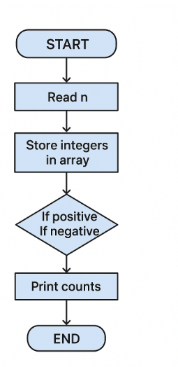
Algorithim
Step 1: Start
Step 2: Read the number of elements n
Step 3: Declare an array of size n
Step 4: Read all n integers into the array
Step 5: Initialize four counters:
- positive = 0
- negative = 0
- odd = 0
- even = 0
Step 6: Traverse each element of the array
• If the number > 0 → increment positive
• If the number < 0 → increment negative
• If the number % 2 == 0 → increment even
• Else → increment odd
Step 7: Display all four counts
Step 8: Stop

pseudo code
START

READ n
DECLARE array[n]

FOR i = 0 to n-1
READ array[i]
END FOR

SET positive = 0
SET negative = 0
SET odd = 0
SET even = 0

FOR i = 0 to n-1
IF array[i] > 0 THEN
positive = positive + 1
ELSE IF array[i] < 0 THEN
negative = negative + 1
END IF

IF array[i] % 2 == 0 THEN
even = even + 1
ELSE
odd = odd + 1
END IF
END FOR

PRINT "Positive numbers =", positive
PRINT "Negative numbers =", negative
PRINT "Even numbers =", even
PRINT "Odd numbers =", odd

STOP
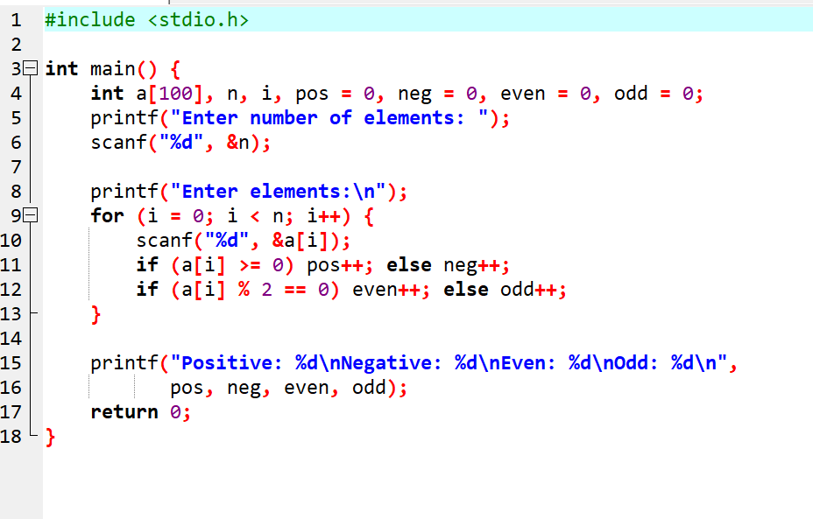
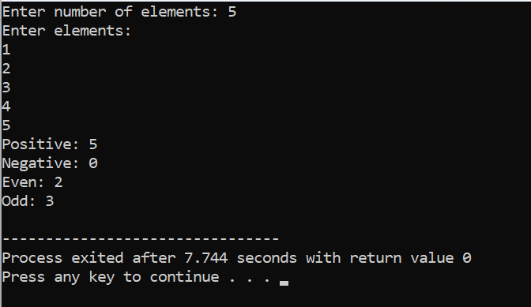

  - . WAP to read a list of integers and store it in a single dimensional array. Write a Cprogram to find the frequency of a particular number in a list of integers.
Flowchart
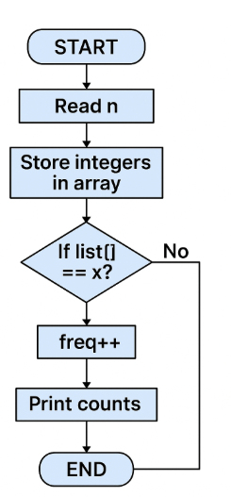
Algorithim
1.Start
Step 2: Read the number of elements n
Step 3: Declare an array of size n
Step 4: Read all n integers into the array
Step 5: Read the number x whose frequency is to be found
Step 6: Initialize count = 0
Step 7: Traverse the array
• If array[i] == x → increment count
Step 8: Print count
Step 9: Stop

Pseudo code
START

READ n
DECLARE array[n]

FOR i = 0 to n-1
READ array[i]
END FOR

READ x // number to search

SET count = 0

FOR i = 0 to n-1
IF array[i] == x THEN
count = count + 1
END IF
END FOR

PRINT "Frequency of ", x, " =", count

STOP
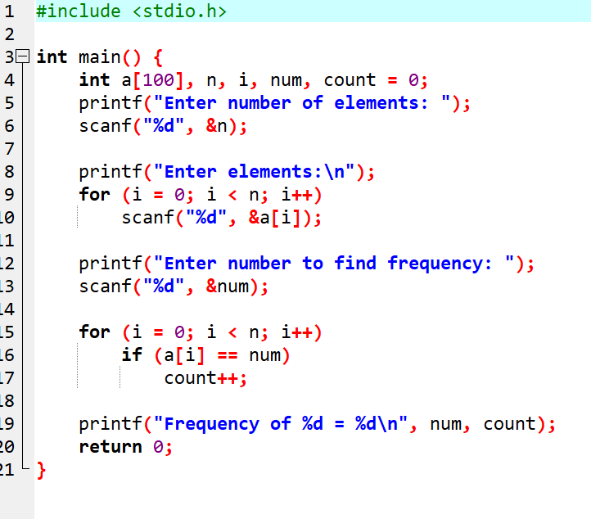
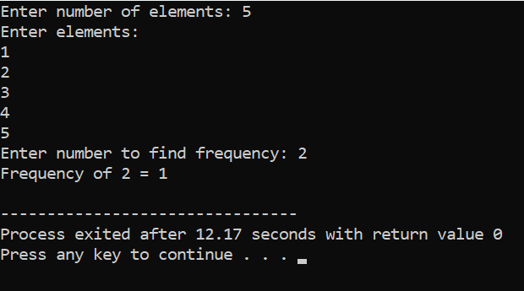

  - WAP that reads two matrices A (m x n) and B (p x q) and computes the product A and B. Read matrix A and matrix B in row major order respectively. Print both the input matrices and resultant matrix with suitable headings and output should be in matrix format only. Program must check the compatibility of orders of the matrices for multiplication. Report appropriate message in case of incompatibility.

Flowchart
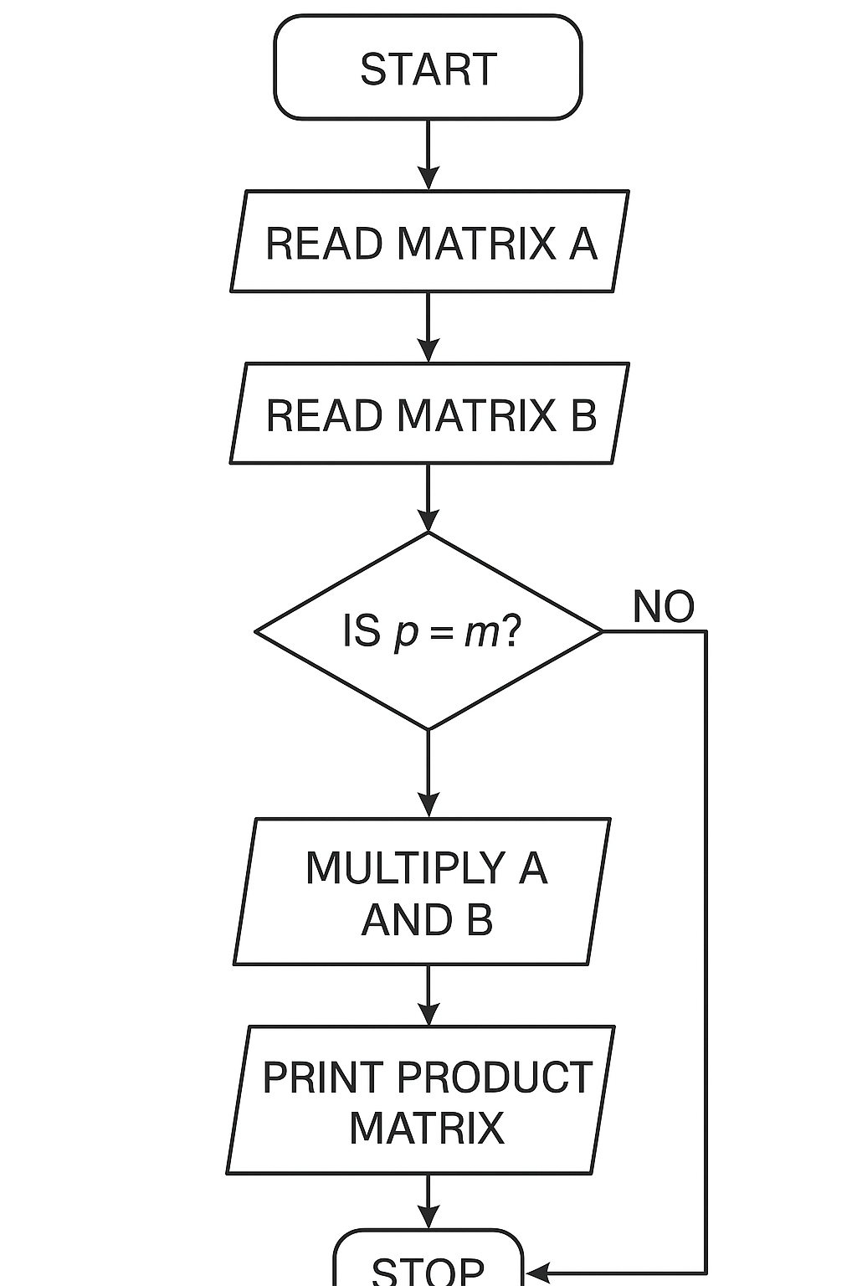

Algorithim

- Step 1: Start
Step 2: Read order of matrix A → m × n
Step 3: Read order of matrix B → p × q
- Step 4: Check compatibility:
• If n != p, then matrix multiplication is not possible
• Print “Matrix multiplication not possible”
• Stop the program
- Step 5: If compatible, continue
- Step 6: Read matrix A in row-major order
Step 7: Read matrix B in row-major order
- Step 8: Declare resultant matrix C of size m × q
- Step 9: Initialize every element of C to 0
- Step 10: Multiply matrices:
For each row i of A
For each column j of B
For each k from 0 to n−1
C[i][j] = C[i][j] + A[i][k] * B[k][j]
- Step 11: Print matrix A
Step 12: Print matrix B
Step 13: Print resultant matrix C
Step 14: Stop
Pseudo code
START

READ m, n
DECLARE A[m][n]

READ p, q
DECLARE B[p][q]

IF n != p THEN
PRINT "Matrix multiplication NOT possible"
STOP
END IF

PRINT "Enter Matrix A:"
FOR i = 0 to m-1
FOR j = 0 to n-1
READ A[i][j]
END FOR
END FOR

PRINT "Enter Matrix B:"
FOR i = 0 to p-1
FOR j = 0 to q-1
READ B[i][j]
END FOR
END FOR

DECLARE C[m][q]

FOR i = 0 to m-1
FOR j = 0 to q-1
C[i][j] = 0
END FOR
END FOR

FOR i = 0 to m-1
FOR j = 0 to q-1
FOR k = 0 to n-1
C[i][j] = C[i][j] + A[i][k] * B[k][j]
END FOR
END FOR
END FOR

PRINT "Matrix A:"
FOR i = 0 to m-1
FOR j = 0 to n-1
PRINT A[i][j]
END FOR
END FOR

PRINT "Matrix B:"
FOR i = 0 to p-1
FOR j = 0 to q-1
PRINT B[i][j]
END FOR
END FOR

PRINT "Resultant Matrix C (A x B):"
FOR i = 0 to m-1
FOR j = 0 to q-1
PRINT C[i][j]
END FOR
END FOR

STOP
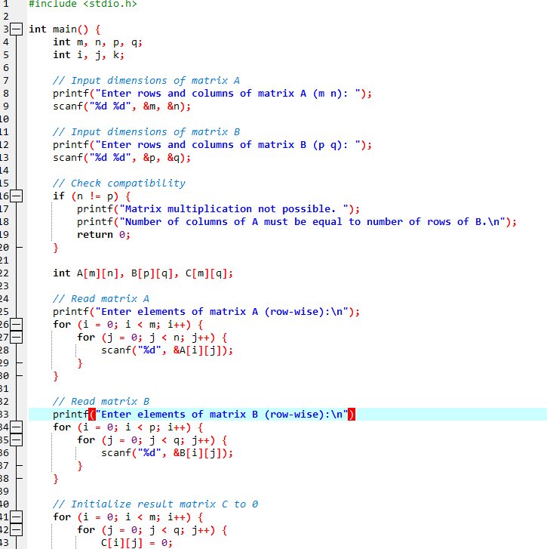
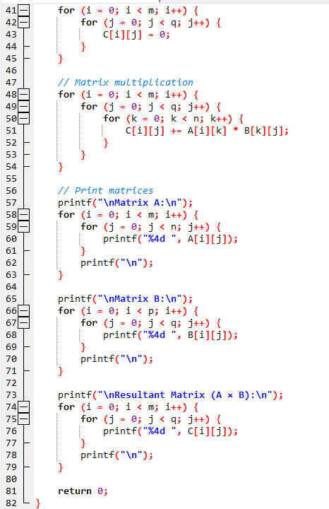
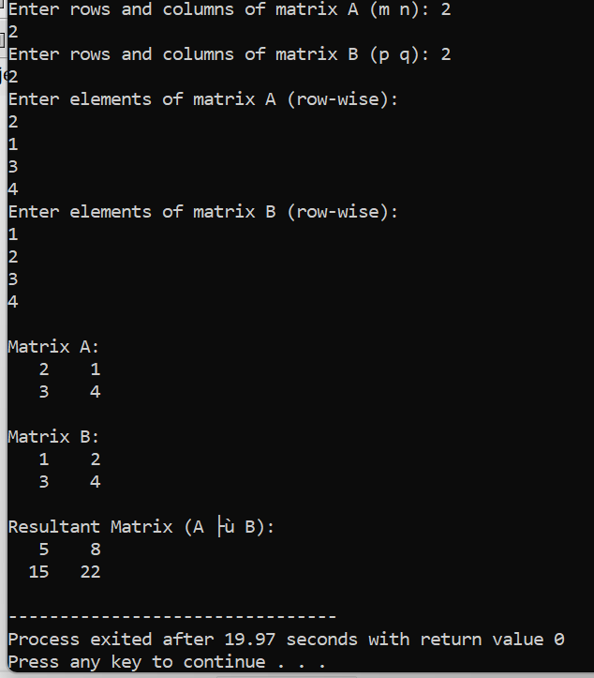

Experiment 6:functions

  - Develop a recursive and non-recursive function FACT(num) to find the factorial of a number, n!, defined by FACT(n) = 1, if n = 0. Otherwise, FACT(n) = n* FACT(n-1). Using this function, write a C program to compute the binomial coefficient. Tabulate the results for different values of n and r with suitable messages
Flowchart
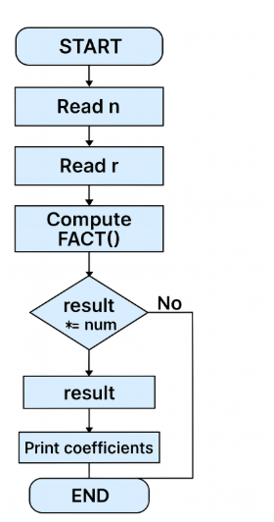
Algorithim

Part A — Recursive FACT(n)
- If n == 0 → return 1
- Else → return n × FACT(n−1)

Part B — Non-recursive FACT(n)
- Set fact = 1
- Loop i from 1 to n
- fact ← fact × i
- Return fact

Part C — Binomial Coefficient
Formula:
$$C(n,r)=\frac{n!}{r!(n-r)!}$$
Steps:
- Read values of n and r
- Compute n!, r!, and (n−r)! using FACT()
- Compute result = n! / (r! × (n−r)!)
- Print result

Part D — Tabulation
- Read how many (n, r) pairs to compute
- For each pair:
  - Compute binomial coefficient
  - Print row: n | r | C(n,r)

Pseudo code
START

// ----------- RECURSIVE FACTORIAL FUNCTION -----------
FUNCTION FACT_RECURSIVE(n)
IF n == 0 THEN
RETURN 1
ELSE
RETURN n * FACT_RECURSIVE(n - 1)
END IF
END FUNCTION

// ----------- NON-RECURSIVE FACTORIAL FUNCTION -----------
FUNCTION FACT_NONRECURSIVE(n)
SET fact = 1
FOR i = 1 TO n
fact = fact * i
END FOR
RETURN fact
END FUNCTION

// ----------- BINOMIAL COEFFICIENT FUNCTION -----------
FUNCTION BINOMIAL(n, r)
num = FACT_NONRECURSIVE(n)
den = FACT_NONRECURSIVE(r) * FACT_NONRECURSIVE(n - r)
RETURN num / den
END FUNCTION

// ---------------- MAIN PROGRAM -------------------
READ t // number of test cases (n,r pairs)

PRINT "n r C(n,r)"
PRINT "---------------------"

FOR i = 1 TO t
READ n, r

IF r > n THEN
PRINT n, r, "Invalid (r cannot be greater than n)"
ELSE
result = BINOMIAL(n, r)
PRINT n, r, result
END IF
END FOR

STOP
Algorithim
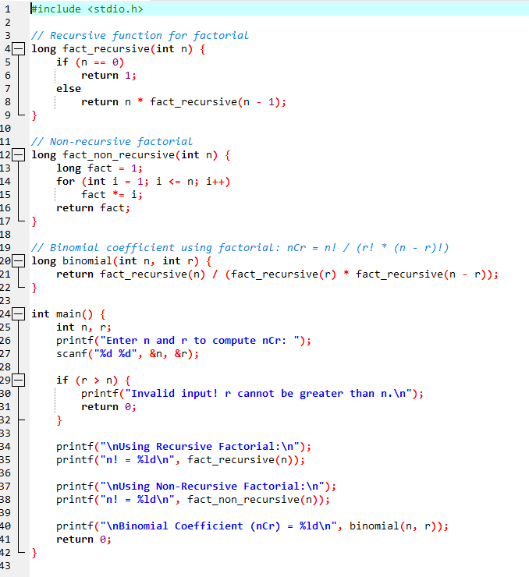
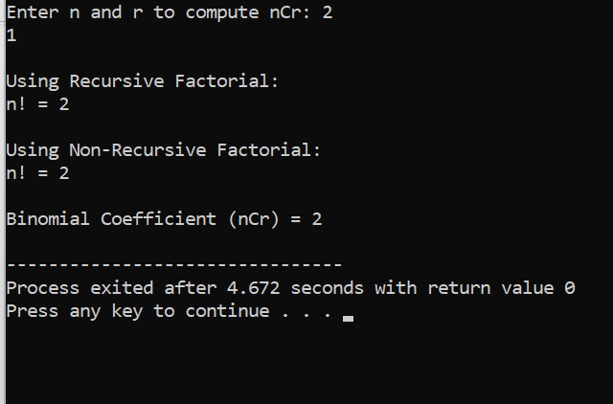
2.Develop a recursive function GCD (num1, num2) that accepts two integer arguments. Write a C program that invokes this function to find the greatest common divisor of two given integers
Flowchart
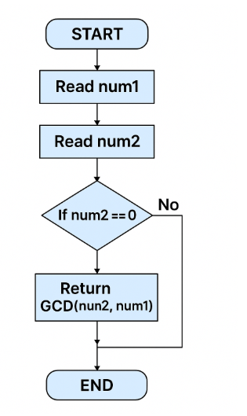
Algorithim
Start
Step 2: Accept two integers num1 and num2
Step 3: If num2 == 0, return num1
Step 4: Else return GCD(num2, num1 % num2)
Step 5: End

Main Program
Step 1: Start
Step 2: Read two integers a and b
Step 3: Call the recursive function GCD(a, b)
Step 4: Store the returned value in result
Step 5: Print result
Step 6: Stop

Pseudo code
START

// --------- RECURSIVE GCD FUNCTION ----------
FUNCTION GCD(num1, num2)
IF num2 == 0 THEN
RETURN num1
ELSE
RETURN GCD(num2, num1 % num2)
END IF
END FUNCTION

// ------------------- MAIN PROGRAM -------------------
READ a
READ b

result = GCD(a, b)

PRINT "GCD of ", a, " and ", b, " is ", result

STOP
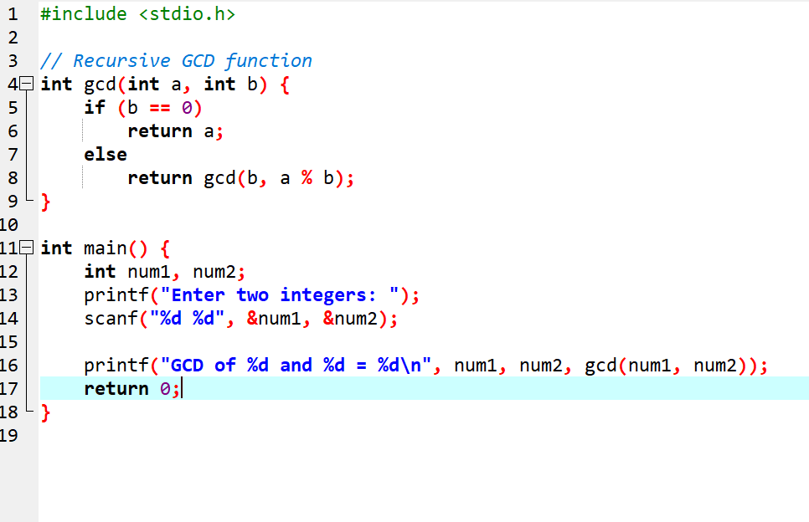
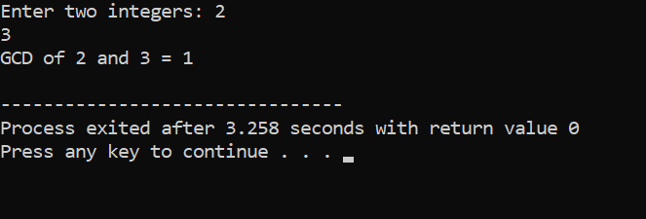

- 3. Develop a recursive function FIBO (num) that accepts an integer argument. Write a C program that invokes this function to generate the Fibonacci sequence up to num
Flowchart
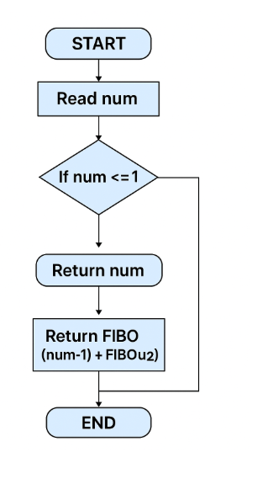
Algorithim
- If num == 0 → return 0
- If num == 1 → return 1
- Otherwise, return FIBO(num−1) + FIBO(num−2)

Main Program
- Start
- Read integer n
- Use a loop from i = 0 to n
- For each i, call FIBO(i)
- Print the returned value
- End
Pseudo code
START

// ------------- RECURSIVE FIBONACCI FUNCTION -------------
FUNCTION FIBO(num)
IF num == 0 THEN
RETURN 0
ELSE IF num == 1 THEN
RETURN 1
ELSE
RETURN FIBO(num - 1) + FIBO(num - 2)
END IF
END FUNCTION

// ---------------------- MAIN PROGRAM ---------------------
READ n // number up to which Fibonacci sequence is required

PRINT "Fibonacci Sequence up to", n, ":"

FOR i = 0 TO n
PRINT FIBO(i)
END FOR

STOP
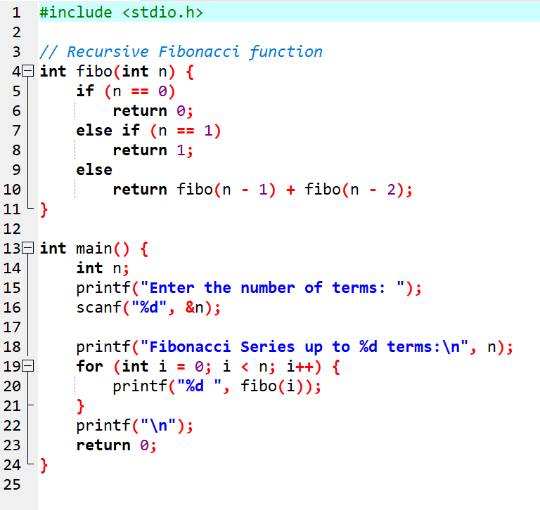

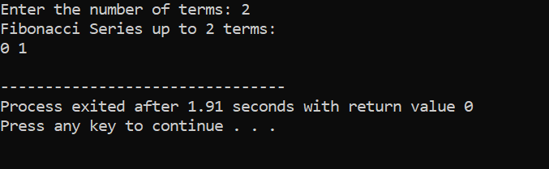
4. Develop a C function ISPRIME (num) that accepts an integer argument and
returns 1 if the argument is prime, a 0 otherwise. Write a C program that
invokes this function to generate prime numbers between the given ranges
flowchart
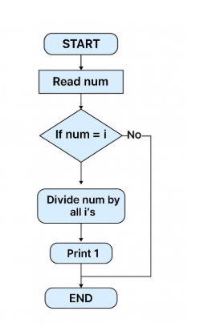
algorithim
- If num ≤ 1, return 0 (not prime)
- For i from 2 to num/2
  - If num % i == 0, return 0 (not prime)
- If no divisor found, return 1 (prime)

Main Program
- Start
- Read the starting number lower
- Read the ending number upper
- For each number from lower to upper
  - Call ISPRIME(number)
  - If it returns 1 → print the number
- Stop

Pseudocode
START

// ------------ PRIME CHECKING FUNCTION -------------
FUNCTION ISPRIME(num)
IF num <= 1 THEN
RETURN 0
END IF

FOR i = 2 TO num/2
IF num % i == 0 THEN
RETURN 0 // Not prime
END IF
END FOR

RETURN 1 // Prime
END FUNCTION

// --------------------- MAIN PROGRAM ---------------------
READ lower
READ upper

PRINT "Prime numbers between ", lower, " and ", upper, " are:"

FOR n = lower TO upper
IF ISPRIME(n) == 1 THEN
PRINT n
END IF
END FOR

STOP
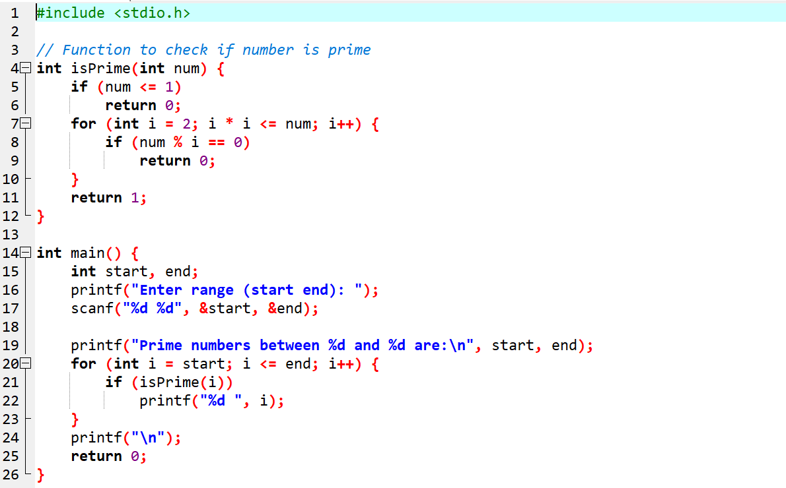
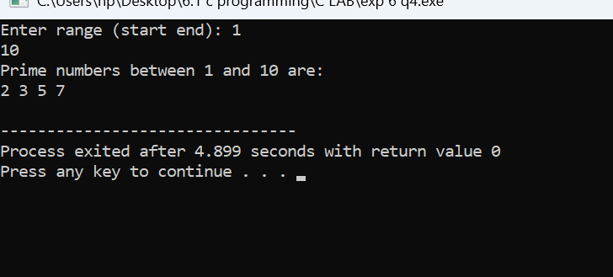
5 5. Develop a function REVERSE (str) that accepts a string argument. Write a C program that invokes this function to find the reverse of a given string.
Flowchart
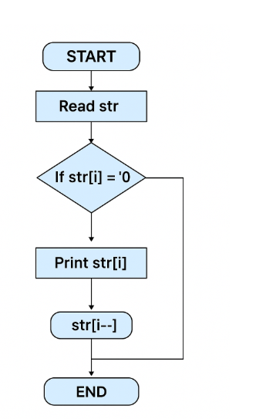
Algorithim

- Read the input string str
- Find the length of the string
- Initialize two indexes:
  - start = 0
  - end = length - 1
- While start < end:
  - Swap characters at start and end
  - Increment start
  - Decrement end
- Return the reversed string

Main Program
- Start
- Read a string from the user
- Call REVERSE(str)
- Print the reversed string
- Stop
Pseudo code
START

// ------------ FUNCTION TO REVERSE STRING --------------
FUNCTION REVERSE(str)
SET start = 0
SET end = LENGTH(str) - 1

WHILE start < end
temp = str[start]
str[start] = str[end]
str[end] = temp

start = start + 1
end = end - 1
END WHILE

RETURN str
END FUNCTION

// ---------------------- MAIN PROGRAM --------------------
DECLARE str

PRINT "Enter a string:"
READ str

rev = REVERSE(str)

PRINT "Reversed string =", rev

STOP

rs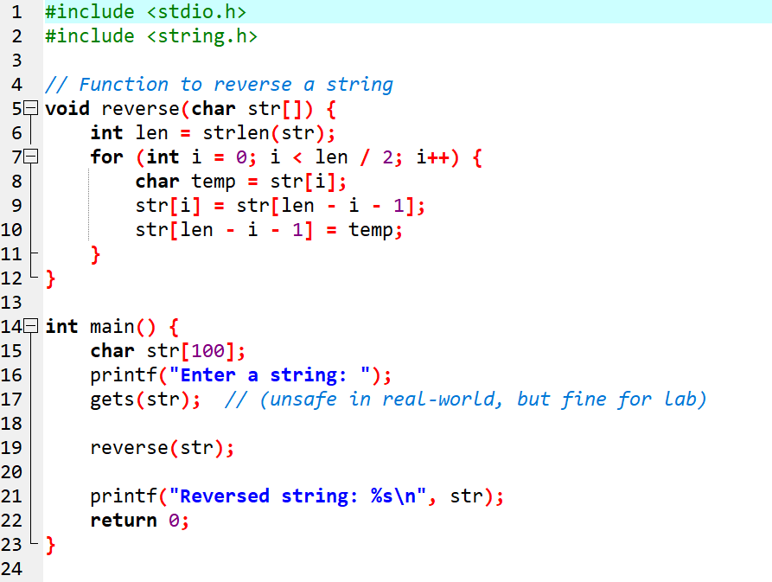
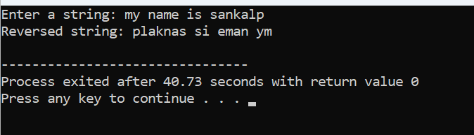

Experiment 7: Structures and Union
  - Write a C program that uses functions to perform the following operations: a. Reading a complex number. b. Writing a complex number. c. Addition and subtraction of two complex numbers

Flowchart

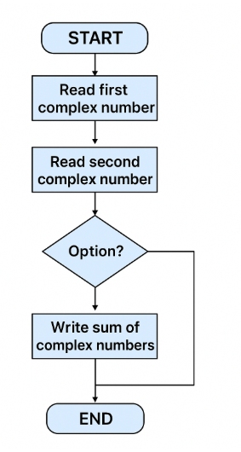

Algorithm
Step 1: Start
Step 2: Define a structure Complex with two members:
- real
- imag
Step 3: Define the following functions:
- readComplex()
  - Read real part
  - Read imaginary part
  - Return complex number
- writeComplex(c)
  - Print real and imaginary parts in proper format
- addComplex(a, b)
  - result.real = a.real + b.real
  - result.imag = a.imag + b.imag
  - Return result
- subComplex(a, b)
  - result.real = a.real - b.real
  - result.imag = a.imag - b.imag
  - Return result
Step 4: In main()
- Declare c1, c2, sum, diff
- Read first complex number using readComplex()
- Read second complex number using readComplex()
- Display both numbers using writeComplex()
- Compute sum using addComplex(c1, c2)
- Compute difference using subComplex(c1, c2)
- Display sum and difference
- Stop

Pseudocode
START

DEFINE STRUCT Complex
real
imag
END STRUCT

FUNCTION readComplex()
DECLARE c AS Complex
READ c.real
READ c.imag
RETURN c
END FUNCTION

FUNCTION writeComplex(c)
PRINT c.real, "+", c.imag, "i"
END FUNCTION

FUNCTION addComplex(a, b)
DECLARE result AS Complex
result.real = a.real + b.real
result.imag = a.imag + b.imag
RETURN result
END FUNCTION

FUNCTION subComplex(a, b)
DECLARE result AS Complex
result.real = a.real - b.real
result.imag = a.imag - b.imag
RETURN result
END FUNCTION

// -------- MAIN PROGRAM --------
DECLARE c1, c2, sum, diff AS Complex

PRINT "Enter first complex number:"
c1 = readComplex()

PRINT "Enter second complex number:"
c2 = readComplex()

PRINT "First complex number:"
writeComplex(c1)

PRINT "Second complex number:"
writeComplex(c2)

sum = addComplex(c1, c2)
diff = subComplex(c1, c2)

PRINT "Sum of complex numbers:"
writeComplex(sum)

PRINT "Difference of complex numbers:"
writeComplex(diff)

STOP

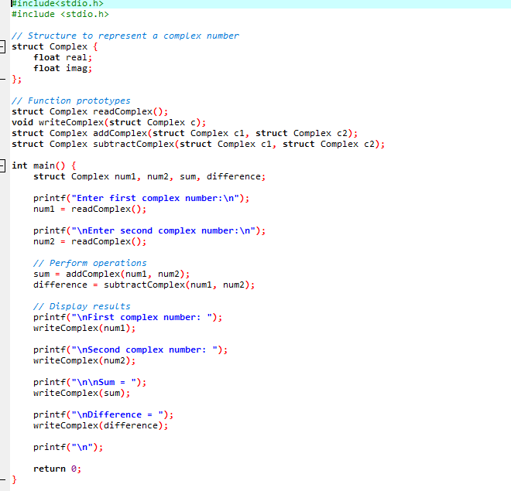
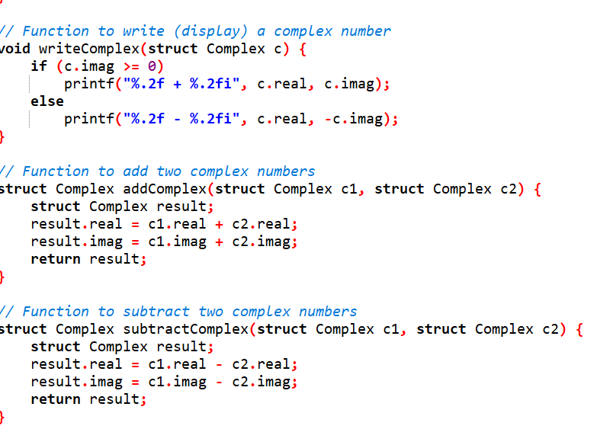
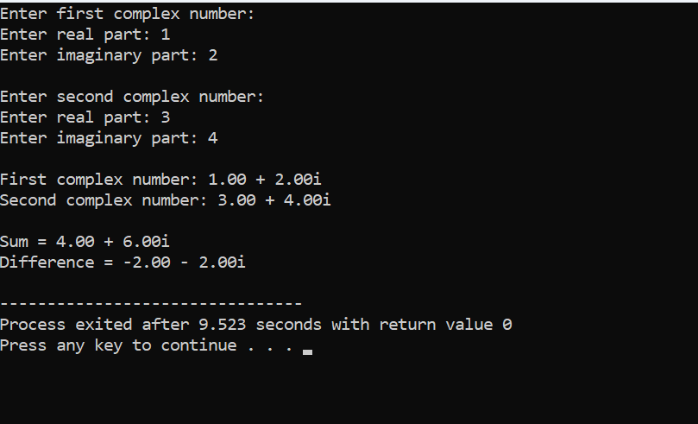

  - Write a C program to compute the monthly pay of 100 employees using each employee‗s name, basic pay. The DA is computed as 52% of the basic pay. Gross-salary (basic pay + DA). Print the employees name and gross salary.
Flowchart
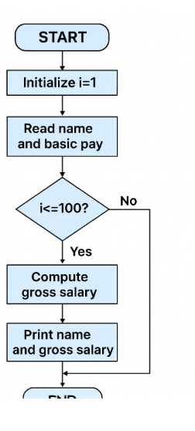

Algorithm
- Start
- Declare an array of 100 employees. Each employee has:
  - Name
  - Basic pay
  - DA (52% of basic pay)
  - Gross salary (Basic + DA)
- For each employee (from 1 to 100):
  - Read the employee’s name
  - Read the employee’s basic pay
  - Compute DA = 52% of basic pay
  - Compute Gross Salary = Basic + DA
- Print the employee name and gross salary for all employees
- Stop
Pseudo code
START

DECLARE Employee[100] STRUCTURE
name
basicPay
DA
grossSalary
END STRUCTURE

FOR i = 0 TO 99
PRINT "Enter name of employee ", i+1, ":"
READ Employee[i].name

PRINT "Enter basic pay of employee ", i+1, ":"
READ Employee[i].basicPay

Employee[i].DA = 0.52 * Employee[i].basicPay
Employee[i].grossSalary = Employee[i].basicPay + Employee[i].DA
END FOR

PRINT "Employee Name Gross Salary"
PRINT "-----------------------------"

FOR i = 0 TO 99
PRINT Employee[i].name, Employee[i].grossSalary
END FOR

STOP
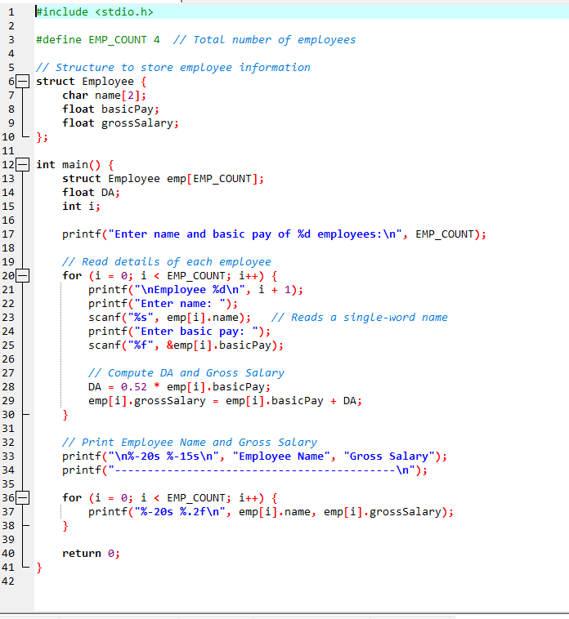
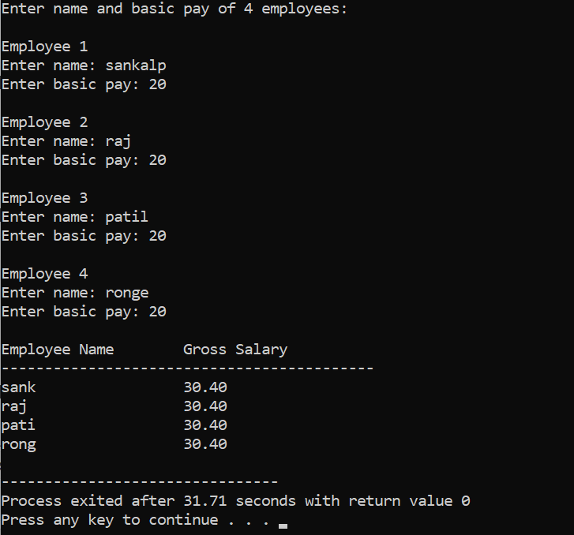

3Create a Book structure containing book_id, title, author name and price. Write a C program to pass a structure as a function argument and print the book details
Flowchart
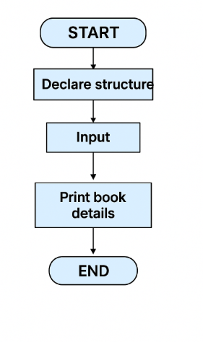
,algorithim
• Start
• Define a Book structure containing:
- book_id
- title
- author
- price
• Define a function printBook(Book b) to display book details:
- Print book_id
- Print title
- Print author
- Print price
• In main():
- Declare a variable b1 of type Book
- Read book details from the user
- Call printBook(b1)
• Stop

Pseudo code
START

DEFINE STRUCT Book
book_id
title
author
price
END STRUCT

FUNCTION printBook(b)
PRINT "Book ID:", b.book_id
PRINT "Title:", b.title
PRINT "Author:", b.author
PRINT "Price:", b.price
END FUNCTION

// ---------------- MAIN PROGRAM ----------------
DECLARE b1 AS Book

PRINT "Enter Book ID:"
READ b1.book_id

PRINT "Enter Book Title:"
READ b1.title

PRINT "Enter Author Name:"
READ b1.author

PRINT "Enter Book Price:"
READ b1.price

CALL printBook(b1)

STOP

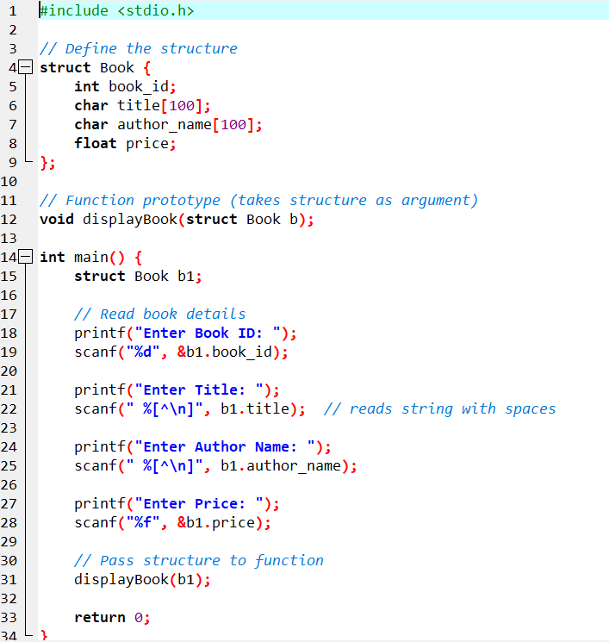

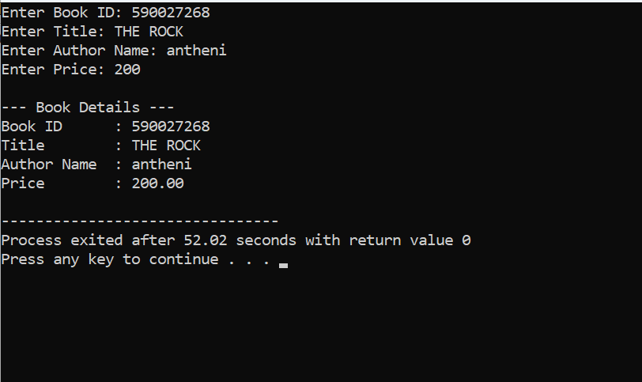

- Create a union containing 6 strings: name, home_address, hostel_address, city, state and zip. Write a C program to display your present address
Flowchart
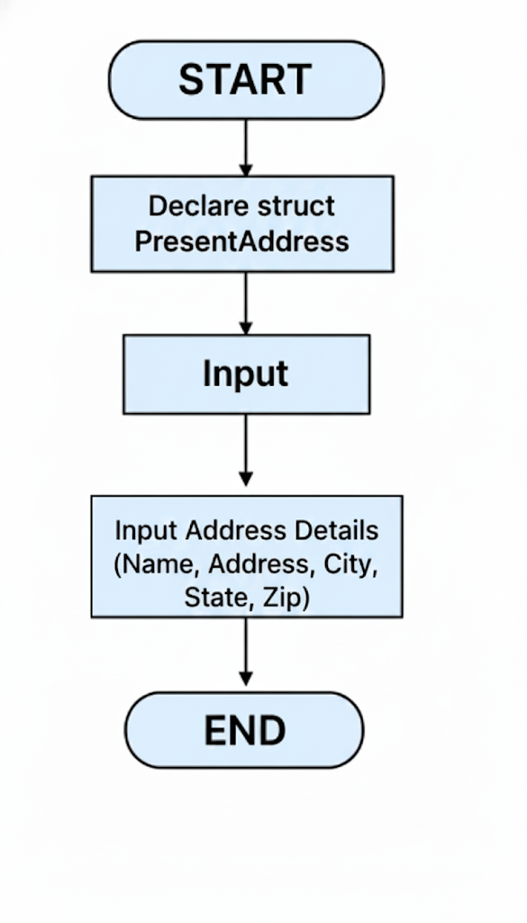
Algorithim
• Start
• Define a union Address containing six strings:
- name
- home_address
- hostel_address
- city
- state
- zip
• Declare a variable addr of type union Address
• Read the present address from the user into one of the union members (e.g., hostel_address)
• Display the present address
• Stop

Pseudo code
START

DEFINE UNION Address
name
home_address
hostel_address
city
state
zip
END UNION

DECLARE addr AS Address

PRINT "Enter your present address:"
READ addr.hostel_address

PRINT "Your present address is:"
PRINT addr.hostel_address

STOP
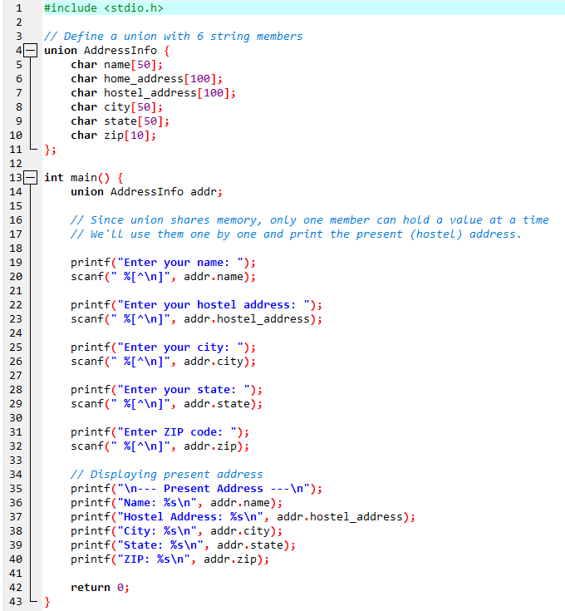
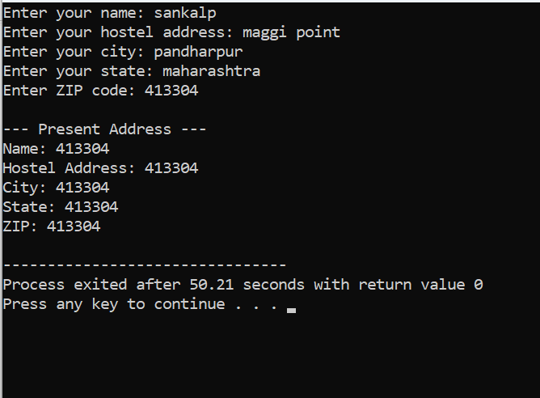
8 pointers
  - Declare different types of pointers (int, float, char) and initialize them with the addresses of variables. Print the values of both the pointers and the variables they point to
Flowchart
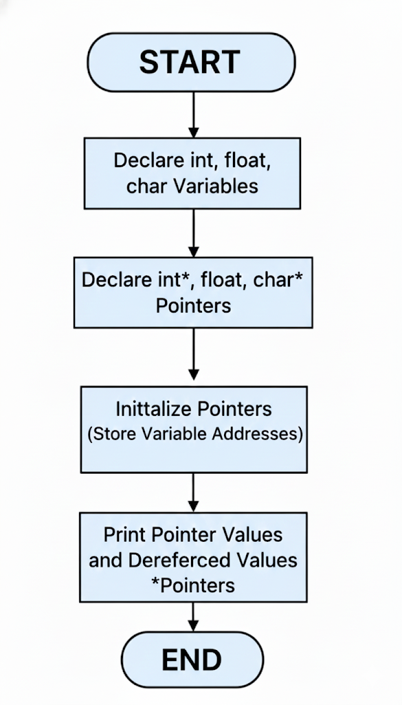
algorithim
- Start
- Declare variables of different types:
  - int a
  - float b
  - char c
- Declare pointers of corresponding types:
  - int *p
  - float *q
  - char *r
- Initialize pointers with the addresses of the respective variables:
  - p = &a
  - q = &b
  - r = &c
- Print the address stored in each pointer
- Print the value pointed to by each pointer (dereference)
- Stop

Pseudo code
START

DECLARE a AS int
DECLARE b AS float
DECLARE c AS char

DECLARE p AS POINTER TO int
DECLARE q AS POINTER TO float
DECLARE r AS POINTER TO char

// Initialize variables
SET a = 10
SET b = 3.14
SET c = 'X'

// Assign addresses to pointers
SET p = ADDRESS OF a
SET q = ADDRESS OF b
SET r = ADDRESS OF c

// Print pointer addresses
PRINT "Address stored in pointer p:", p
PRINT "Address stored in pointer q:", q
PRINT "Address stored in pointer r:", r

// Print values pointed by pointers
PRINT "Value pointed by p:", VALUE AT p
PRINT "Value pointed by q:", VALUE AT q
PRINT "Value pointed by r:", VALUE AT r

STOP
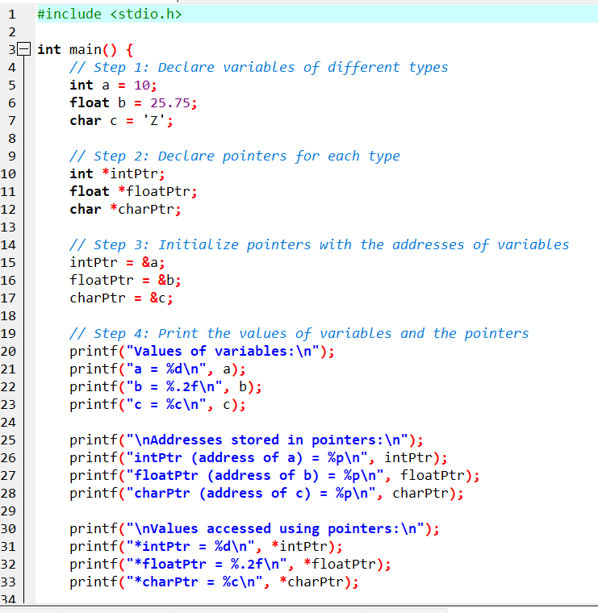

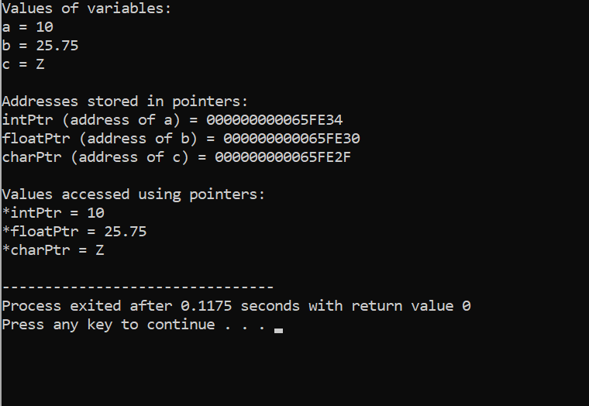

  - Perform pointer arithmetic (increment and decrement) on pointers of different data types. Observe how the memory addresses change and the effects on data access
  - 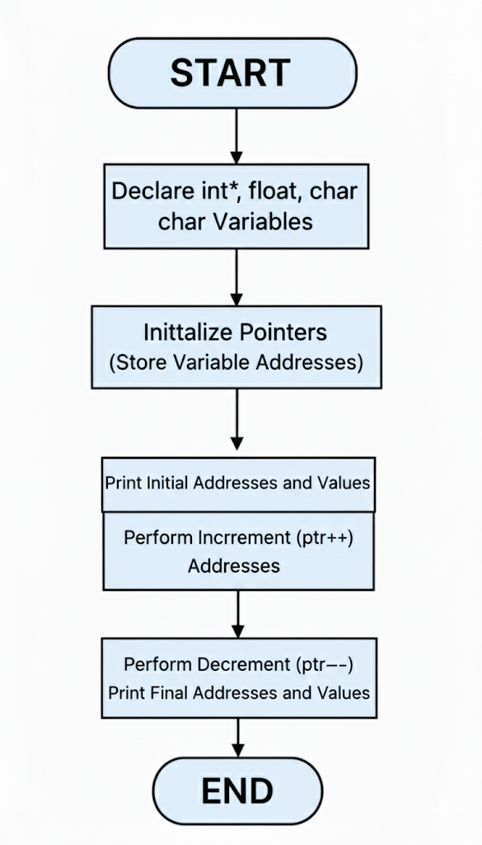
Algorithm
- Start
- Declare variables of types int, float, and char
- Declare corresponding pointers and assign addresses of the variables
- Print initial pointer values (addresses)
- Increment the pointers and print new addresses and values they point to
- Decrement the pointers and print new addresses and values
- Stop
Pseudo code
START

DECLARE a AS int, b AS float, c AS char
SET a = 10, b = 3.14, c = 'X'

DECLARE p AS POINTER TO int = ADDRESS OF a
DECLARE q AS POINTER TO float = ADDRESS OF b
DECLARE r AS POINTER TO char = ADDRESS OF c

PRINT "Original Addresses and Values:"
PRINT p, *p
PRINT q, *q
PRINT r, *r

INCREMENT p
PRINT "After p++:", p, *p

INCREMENT q
PRINT "After q++:", q, *q

INCREMENT r
PRINT "After r++:", r, *r

DECREMENT p
PRINT "After p--:", p, *p

DECREMENT q
PRINT "After q--:", q, *q

DECREMENT r
PRINT "After r--:", r, *r

STOP

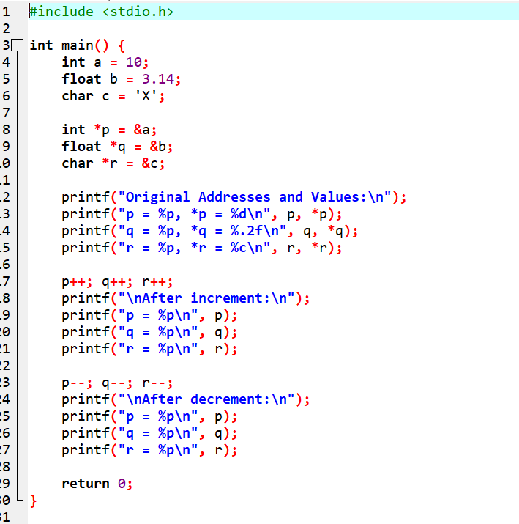

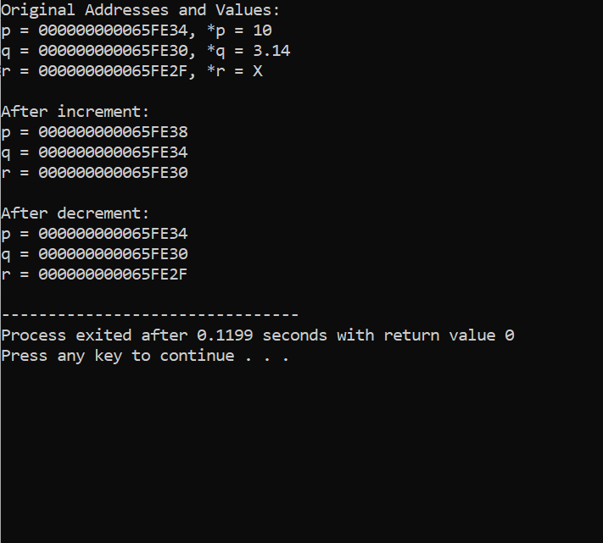
4 Write a function that accepts pointers as parameters. Pass variables by reference using pointers and modify their values within the function. i want algorithim pseudo code and code of both questions diifernt

Algorithm
- Start
- Declare variables a, b
- Define a function modify that accepts pointers to a and b
  - Inside the function, modify the values via pointers
- Call the function from main and pass addresses of a and b
- Print values before and after function call to observe changes
- Stop
Pseudo code
START

DECLARE a AS int, b AS float, c AS char
SET a = 10, b = 3.14, c = 'X'

DECLARE p AS POINTER TO int = ADDRESS OF a
DECLARE q AS POINTER TO float = ADDRESS OF b
DECLARE r AS POINTER TO char = ADDRESS OF c

PRINT "Original Addresses and Values:"
PRINT p, *p
PRINT q, *q
PRINT r, *r

INCREMENT p
PRINT "After p++:", p, *p

INCREMENT q
PRINT "After q++:", q, *q

INCREMENT r
PRINT "After r++:", r, *r

DECREMENT p
PRINT "After p--:", p, *p

DECREMENT q
PRINT "After q--:", q, *q

DECREMENT r
PRINT "After r--:", r, *r

STOP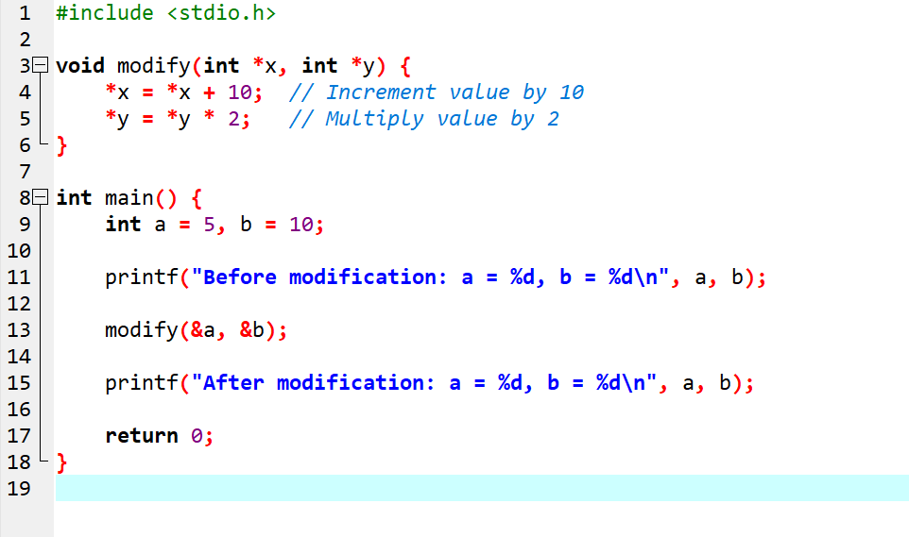
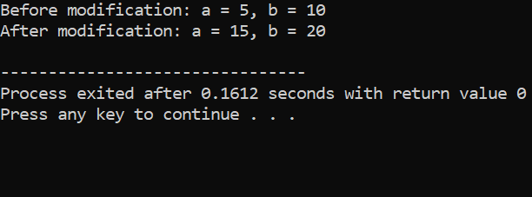

Experiment 9: File Handling in C
  - Write a program to create a new file and write text into it
Algorithim
Algorithm
- Start
- Declare a file pointer FILE *fp
- Open a new file in write mode using fopen()
  - If the file cannot be opened, display an error and exit
- Ask the user to enter the text to write into the file
- Use fprintf() or fputs() to write the text into the file
- Close the file using fclose()
- Display a message that writing is successful
- Stop
Pseudo code
START

DECLARE fp AS FILE POINTER

OPEN file "output.txt" IN WRITE MODE AND ASSIGN TO fp
IF fp IS NULL THEN
PRINT "Error: Cannot create file"
STOP
END IF

PRINT "Enter text to write to file:"
READ text

WRITE text TO fp

CLOSE fp

PRINT "Text written to file successfully."

STOP

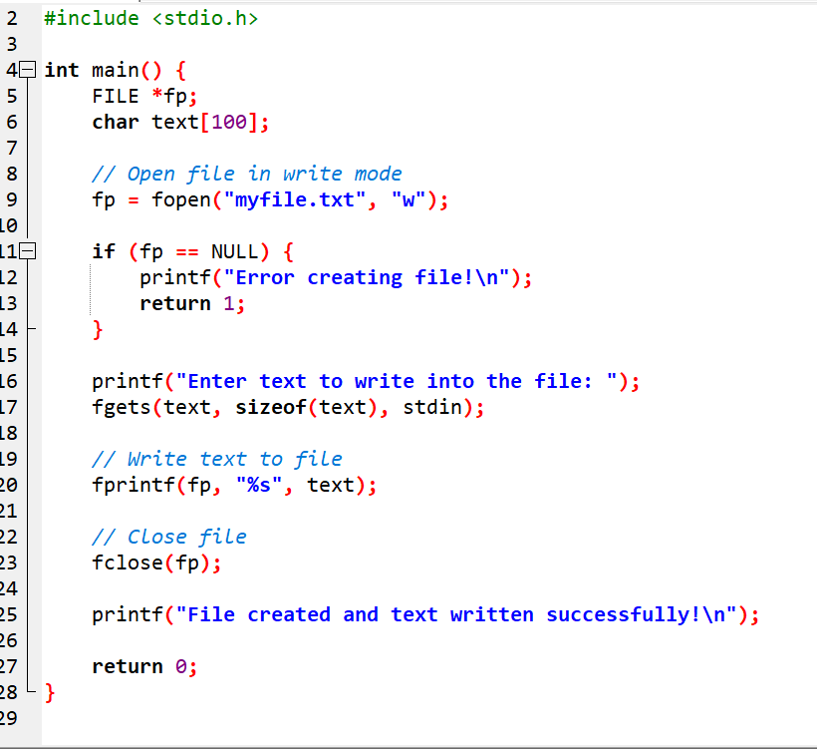

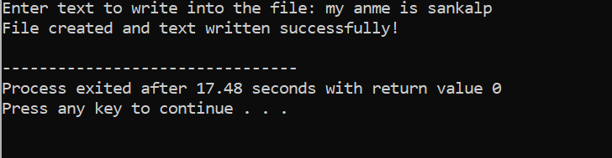

. 2. Open an existing file and read its content character by character, and then close the file
Algorithm
- Start
- Declare a file pointer FILE *fp
- Open an existing file in read mode using fopen()
  - If the file cannot be opened, display an error message and stop
- Read characters one by one using fgetc()
- While not end of file (EOF), display each character on the screen
- Close the file using fclose()
- Stop

Pseudo code
START

DECLARE fp AS FILE POINTER
DECLARE ch AS CHARACTER

OPEN file "input.txt" IN READ MODE AND ASSIGN TO fp
IF fp IS NULL THEN
PRINT "Error: Cannot open file"
STOP
END IF

READ ch = fgetc(fp)

WHILE ch IS NOT EOF DO
PRINT ch
READ ch = fgetc(fp)
END WHILE

CLOSE fp

STOP
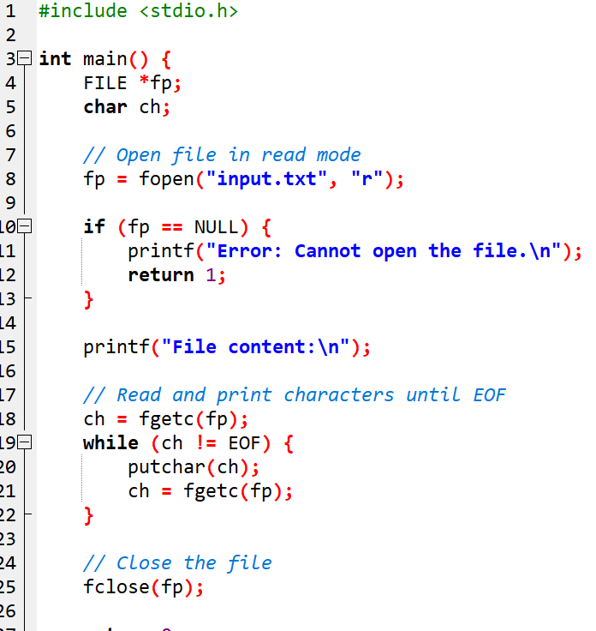

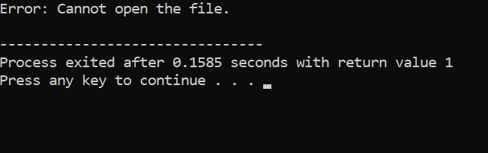

3Open a file, read its content line by line, and display each line on the console.
Algorithm
- Start
- Declare a file pointer FILE *fp
- Open an existing file in read mode using fopen()
  - If file fails to open, display an error and exit
- Declare a character array (buffer) to store each line
- Use fgets() to read one line at a time
- While the line is not NULL:
  - Print the line
  - Read next line
- Close the file using fclose()
- Stop
Pseudo code
START

DECLARE fp AS FILE POINTER
DECLARE line AS STRING[200]

OPEN "input.txt" IN READ MODE AND ASSIGN TO fp
IF fp IS NULL THEN
PRINT "Error: Cannot open file"
STOP
END IF

READ line = fgets(buffer, size, fp)

WHILE line IS NOT NULL DO
PRINT line
READ line = fgets(buffer, size, fp)
END WHILE

CLOSE fp

STOP
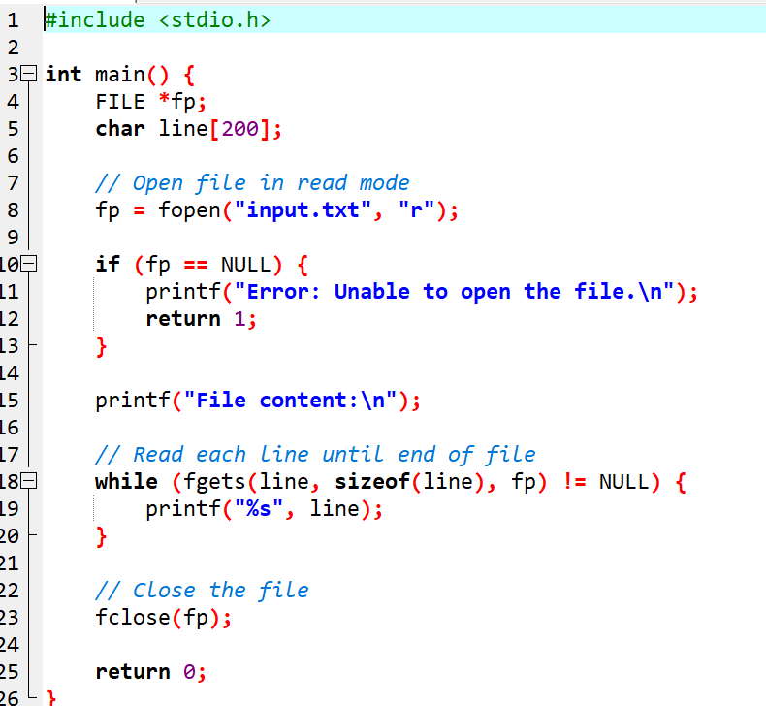
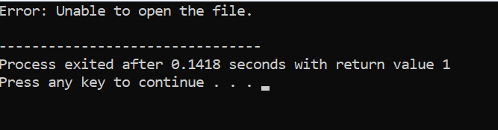

Experiment 10: Dynamic Memory Allocation
4 Write a function that accepts pointers as parameters. Pass variables by reference using pointers and modify their values within the function. i want algorithim pseudo code and code of both questions diifernt.
Algorithm
Algorithm: Modify Values Using Pointers
• Start
• Declare two integer variables a and b.
• Read values of a and b from the user.
• Call the function modify(&a, &b) and pass addresses.
• Inside the function:
- Increase value of a by 10
- Multiply b by 2
• Return to main program.
• Display modified values of a and b.
• End.

Pseudo code
BEGIN
DECLARE a, b

PRINT "Enter two numbers"
INPUT a, b

CALL modify(a_address, b_address)

PRINT "New value of a:", a
PRINT "New value of b:", b
END

FUNCTION modify(ptr1, ptr2)
*ptr1 = *ptr1 + 10
*ptr2 = *ptr2 * 2
END FUNCTION

Screenshot:
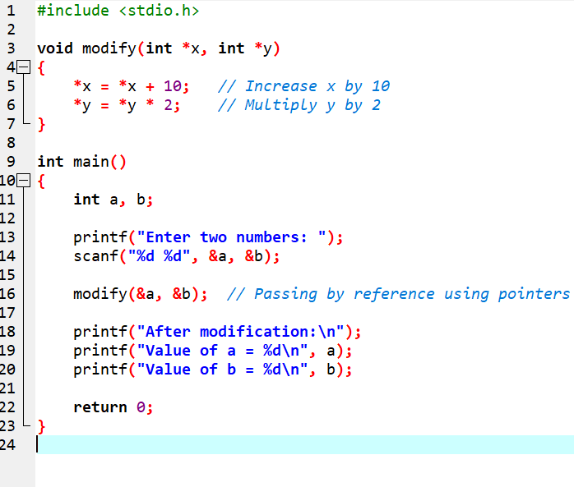

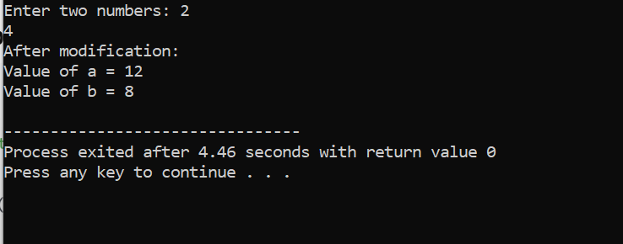

  - Write a program to insert item in middle of the linked list.
Algorithm: Insert in Middle of Linked List
- Start
- Create a structure node with data and next.
- Create the linked list or take existing list.
- Input the new value to insert.
- Count the total number of nodes.
- Calculate middle position → mid = count / 2
  - (For even nodes, insert after count/2 node)
- Traverse the list until the (mid)th node.
- Create new node.
- Set:
  - newnode->next = current->next
  - current->next = newnode
- Display the updated list.
- End.

2. Pseudo-code
BEGIN
CREATE Linked List
INPUT new_value

SET count = 0
temp = head

WHILE temp IS NOT NULL
count = count + 1
temp = temp.next
END WHILE

mid = count / 2

temp = head
i = 1
WHILE i < mid
temp = temp.next
i = i + 1
END WHILE

CREATE newnode
newnode.data = new_value

newnode.next = temp.next
temp.next = newnode

PRINT updated list
END

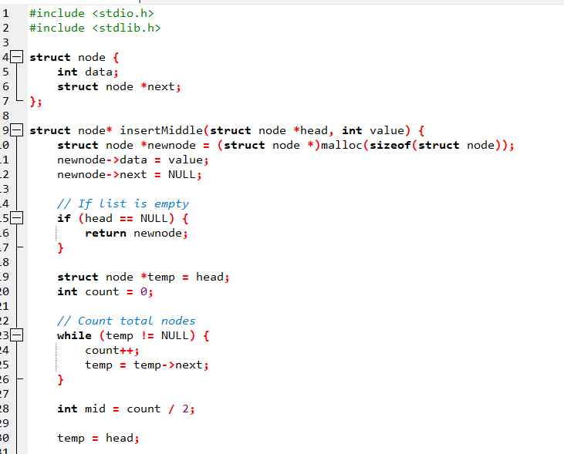

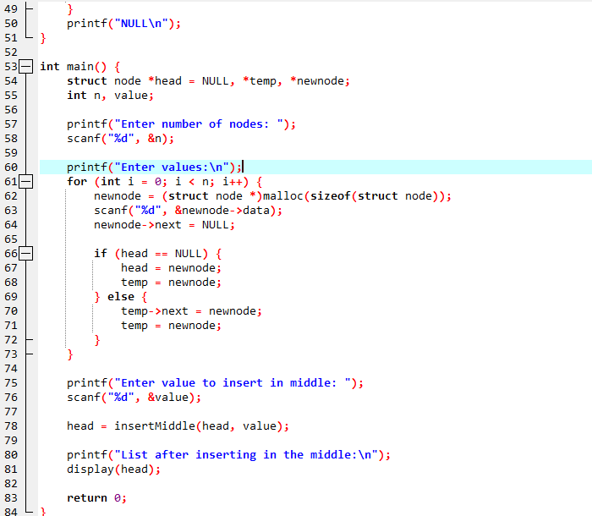
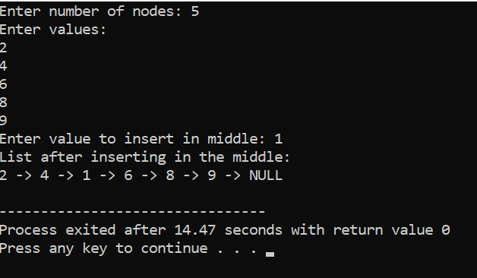

Experiment 11: Bitwise Operator
Algorithm: Bitwise Operations
- Start
- Declare three integer variables: a, b, result.
- Read values of a and b.
- Apply bitwise AND: result = a & b
- Apply bitwise OR: result = a | b
- Apply bitwise NOT:
  - result = ~a
  - result = ~b
- Display the results.
- End.

Pseudo code

BEGIN
DECLARE a, b, and_result, or_result, not_a, not_b

PRINT "Enter two numbers"
INPUT a, b

and_result = a AND b
or_result = a OR b
not_a = NOT a
not_b = NOT b

PRINT "Bitwise AND =", and_result
PRINT "Bitwise OR =", or_result
PRINT "Bitwise NOT of a =", not_a
PRINT "Bitwise NOT of b =", not_b
END
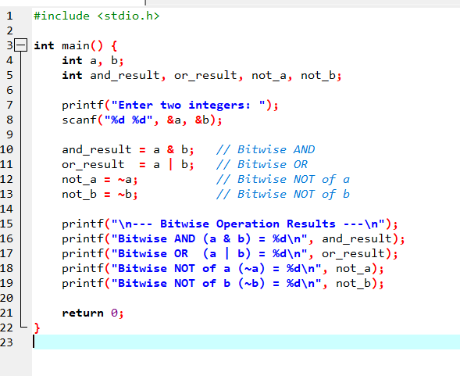
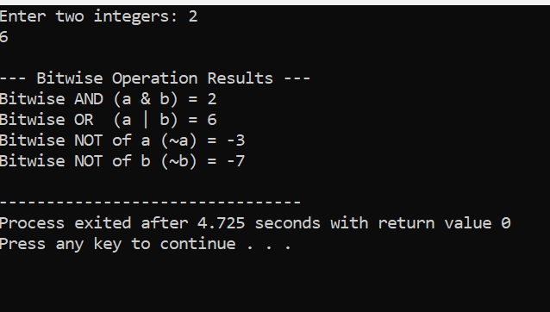

  - Write a program to apply left shift and right shift operator
Algorithm: Left Shift & Right Shift
- Start
- Declare integers: num, left_result, right_result, shift.
- Read number num from user.
- Read shift count shift from user.
- Compute left shift:
  - left_result = num << shift
- Compute right shift:
  - right_result = num >> shift
- Display results.
- End.

Pseudo code

BEGIN
DECLARE num, shift
DECLARE left_result, right_result

PRINT "Enter a number"
INPUT num

PRINT "Enter shift count"
INPUT shift

left_result = num LEFTSHIFT shift
right_result = num RIGHTSHIFT shift

PRINT "Left Shift Result =", left_result
PRINT "Right Shift Result =", right_result
END

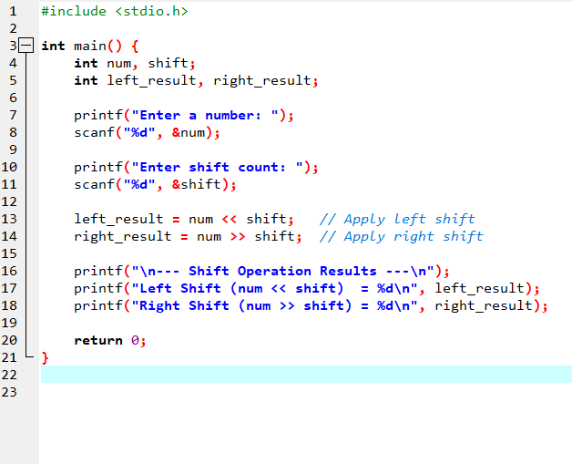
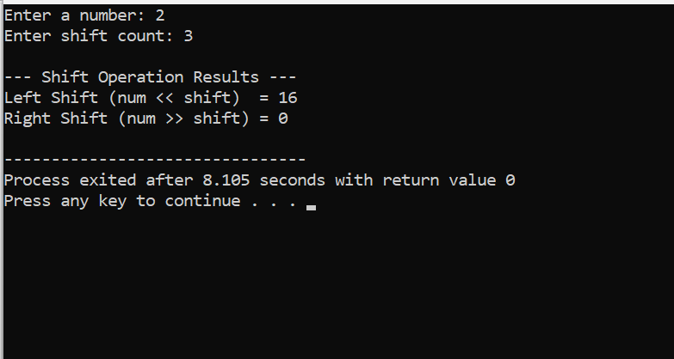

Experiment 12: Preprocessor and Directives in C
  - Write a program to define some constant variable in preprocessor.
Algorithm
- Start
- Use #define to declare constant values (e.g., PI, MAX, MIN).
- Print the constant values inside main() using printf().
- End
START

DEFINE PI = 3.14
DEFINE MAX = 100
DEFINE MIN = 10

PRINT "Value of PI =", PI
PRINT "Maximum value =", MAX
PRINT "Minimum value =", MIN

END

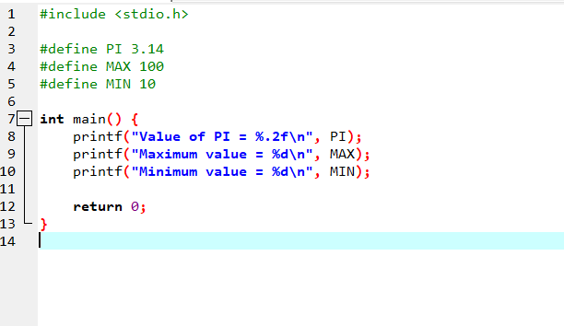
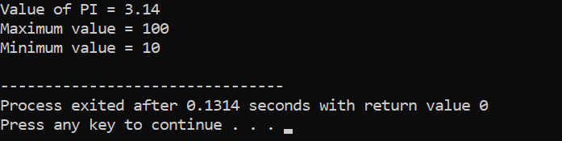

2.Write a program to define a function in directives
Algorithm
- Start the program.
- Define a macro function using #define (e.g., SQUARE(x) to calculate square).
- Declare main function.
- Read an integer value from the user.
- Call the macro function using the input value.
- Display the result.
- End program.

Pseudo code
START
DEFINE macro function SQUARE(x) = (x * x)

PRINT "Enter a number:"
READ num

result = SQUARE(num)

PRINT "Square =", result
END
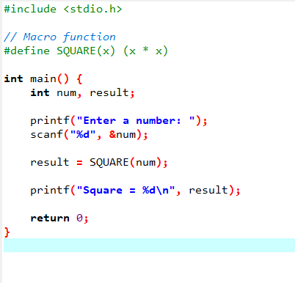
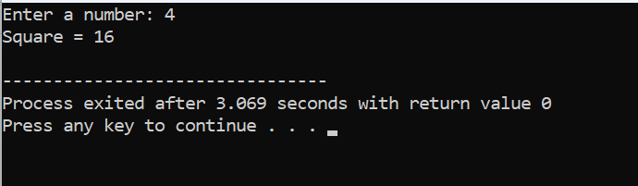

Experiment 13: Macros in C
  - Write a program to define multiple macro to perform arithmetic functions
Algorithm
- Start the program.
- Define multiple macro functions using #define:
  - ADD(a, b)
  - SUB(a, b)
  - MUL(a, b)
  - DIV(a, b)
- In main(), declare variables for input.
- Ask the user to enter two numbers.
- Use each macro to perform the arithmetic operation.
- Display the results.
- End the program.

Pseudo code
START
DEFINE ADD(a, b) = (a + b)
DEFINE SUB(a, b) = (a - b)
DEFINE MUL(a, b) = (a * b)
DEFINE DIV(a, b) = (a / b)

PRINT "Enter two numbers:"
READ num1, num2

sum = ADD(num1, num2)
diff = SUB(num1, num2)
prod = MUL(num1, num2)
quot = DIV(num1, num2)

PRINT all results
END

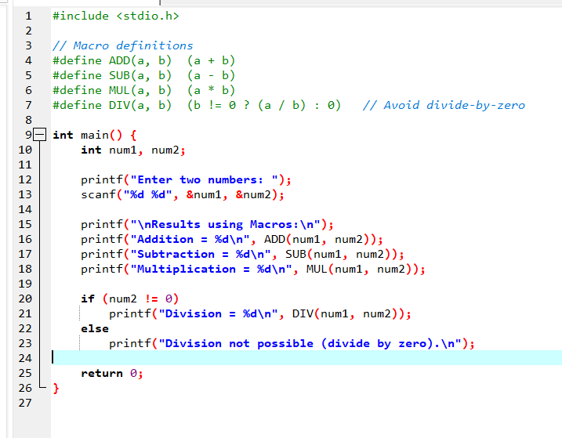
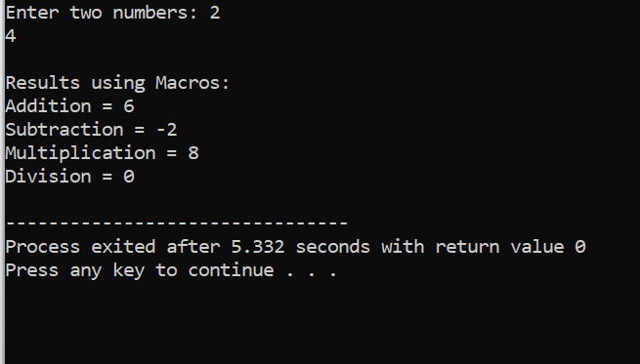

Experiment 14: Static Library in C
  - Write a program to create a static library for performing arithmetic functions.
ALGORITHM
- Start.
- Create a header file containing arithmetic function prototypes.
- Create a source file containing function definitions.
- Compile the source file into an object file (.o).
- Create the static library using the ar command.
- Create a main.c file that includes the header and calls the functions.
- Compile the main program and link it with the static library.
- Run the program and display results.
- End.
Pseudocode
START
Create header file: arithmetic.h
Create source file: arithmetic.c containing functions:
add(a,b)
sub(a,b)
mul(a,b)
div(a,b)

Compile arithmetic.c → arithmetic.o

Create static library → libarith.a using ar command

Write main.c:
include "arithmetic.h"
read a, b
call add, sub, mul, div
print results

Compile main program with library
END

Header file
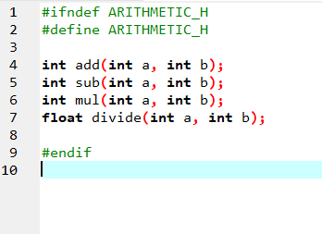

Source file
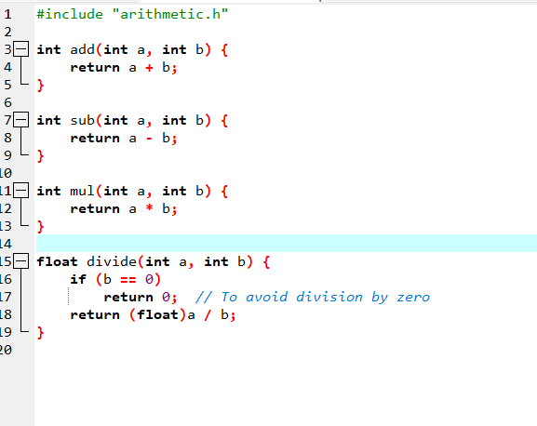
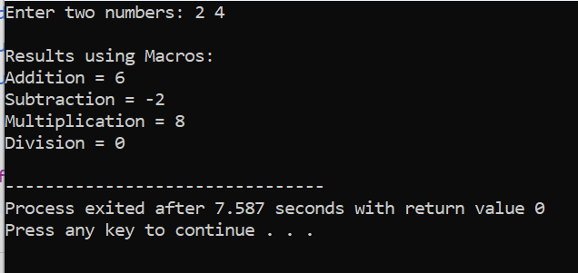

  - Write a program to use static library in other program.
ALGORITHM
1: Create Arithmetic Functions
- Start
- Create a C file (e.g., arith.c)
- Define functions such as add(), sub(), mul(), div()
- Save the file

Step 2: Create Static Library
• Compile arith.c into object code
- gcc -c arith.c
• Create static library
- ar rcs libarith.a arith.o
• Save the library
3: Use the Library in Another Program
- Create a new C program file (e.g., main.c)
- Include the header file arith.h
- Call the arithmetic functions
- Compile program with library
  - gcc main.c -L. -larith -o output
- Run the program

Pseudo code
BEGIN

// Step 1: Create arithmetic functions
DEFINE function add(a, b)
RETURN a + b

DEFINE function sub(a, b)
RETURN a - b

DEFINE function mul(a, b)
RETURN a * b

DEFINE function div(a, b)
RETURN a / b

// Step 2: Create static library from these functions
// gcc -c arith.c
// ar rcs libarith.a arith.o

// Step 3: Use library in another program
READ a, b from user
PRINT "Addition =", add(a, b)
PRINT "Subtraction =", sub(a, b)
PRINT "Multiplication =", mul(a, b)
PRINT "Division =", div(a, b)

END
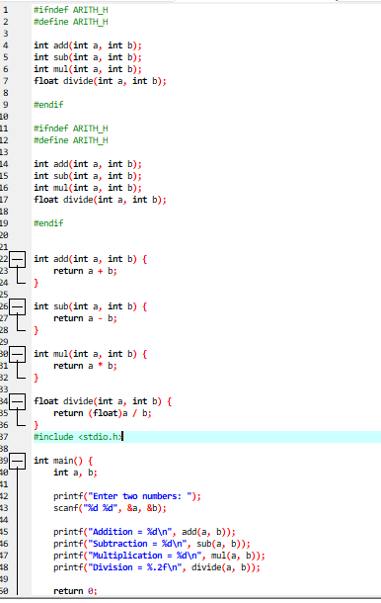
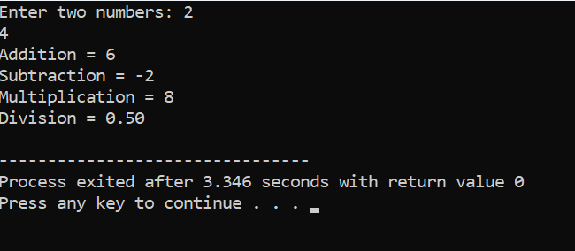
Experiment 15: Shared Library in C
  - Write a program to create a shared library for performing arithmetic functions
Algorithm
Step 1: Create Arithmetic Functions
- Start
- Create a C file (e.g., arith.c)
- Write functions for
  - addition
  - subtraction
  - multiplication
  - division
- Save the file

Step 2: Create Shared Library
- Compile source file with -fPIC (Position Independent Code)
- Create shared library using gcc -shared
- Save the library as libarith.so

Step 3: Use Shared Library in Another Program
- Create a separate C program (main.c)
- Include the header file
- Call arithmetic functions
- Compile and link program using -larith
- Set LD_LIBRARY_PATH to load the shared library
- Run the program
Pseudo code
BEGIN

DEFINE function add(a, b) RETURN a + b
DEFINE function sub(a, b) RETURN a - b
DEFINE function mul(a, b) RETURN a * b
DEFINE function divide(a, b) RETURN a / b

// Compile with PIC and create shared library
// gcc -fPIC -c arith.c
// gcc -shared -o libarith.so arith.o

// Using library in main program
READ a, b
PRINT add(a, b)
PRINT sub(a, b)
PRINT mul(a, b)
PRINT divide(a, b)

END
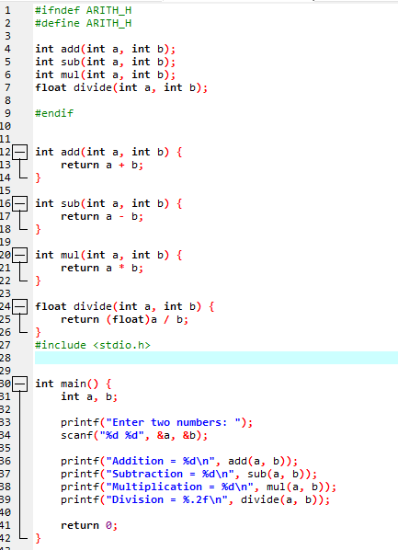

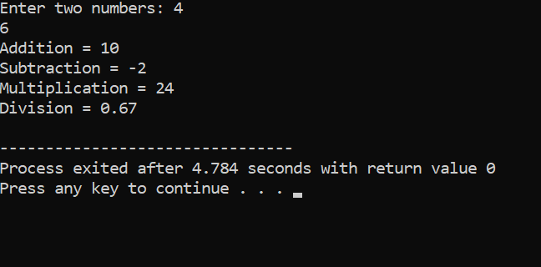

  - Write a program to use shared library in another program
Algorithm
- Start
- Include the shared library header file (arith.h) in the program
- Take two integers as input from the user
- Call shared library functions:
  - add(a, b)
  - sub(a, b)
  - mul(a, b)
  - divide(a, b)
- Display the results
- End
Pseudo code
BEGIN

INPUT a, b

result1 = add(a, b)
result2 = sub(a, b)
result3 = mul(a, b)
result4 = divide(a, b)

PRINT result1
PRINT result2
PRINT result3
PRINT result4

END

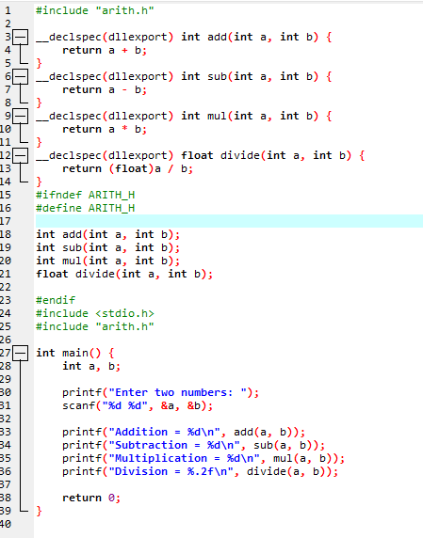

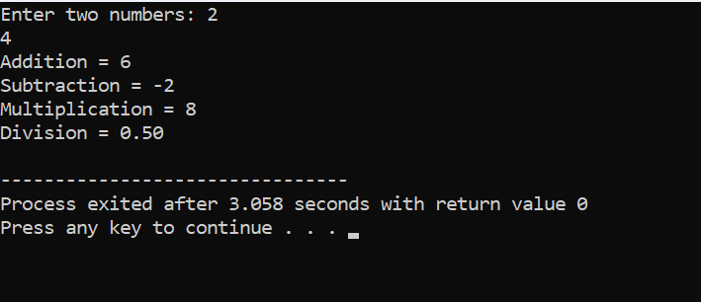

Experiment 16: Multithreading in C
  - Write a program to print 1-10 numbers five times using multithreading in C
Algorithm
- Start program
- Create a thread function printNumbers()
- Inside the function, loop 5 times
  - In each iteration print numbers 1 to 10
- In main() create a thread using pthread_create()
- Wait for the thread to finish using pthread_join()
- End program

Pseudo code
FUNCTION printNumbers
REPEAT 5 times
FOR i = 1 to 10
PRINT i
END FOR
PRINT newline
END REPEAT
END FUNCTION

MAIN
CREATE thread and run printNumbers
WAIT for thread to complete
END MAIN
